The Cinnamon Desktop Environment

The official user guide can be found here:
- https://www.linuxmint.com/documentation.php
- you might also want to take a look at the basic components of a desktop in general. The videos were made by Joe Collins:
Beginner's Guide To The Desktop 1 | Introduction https://www.youtube.com/watch?v=866-MpRATnM

This is going to focus on the Cinnamon Desktop Environment, please read the documentation above for other information. Also this document is (at this time) limited to my own knowledge of the desktop. This is not a short read either. The way this was structured was in a “one thing leads to the next” sort of way.

Table of contents

- The menu
  - the menu layout
  - the menu configuration
  - the menu editor
- The panel
  - The applets
    - the sound applet and sound settings
    - update manager
      - software sources
      - linux kernel
      - driver manager
    - calendar and date&time settings
    - expo and workspaces
    - available applets
- The Desklets
- The Themes
- The Extensions
- The Effects
- Backgrounds
- Fonts
- Accessibility
- Account details
- Users and groups
- The Desktop
  - hidden files
  - sudo and root
  - Nemo
    - layout
    - file
    - edit
      - preferences
        - view
        - behavior
        - display
        - list columns
        - preview
        - toolbar
      - plugins
    - view
    - go
    - bookmarks
    - about
- General
- Hot corners
- Languages and Input method
- Keyboard
- Startup Applications
- Notifications
- Privacy
- Preferred Applications
- Screensaver
- Login Window
- Windows
- Window tilling
- Display
- Mouse and touchpad
- Networking
- Power Management
- System Info

The menu
The menu layout

The menu in located in the left corner of the screen, in the panel (the taskbar in Windows).

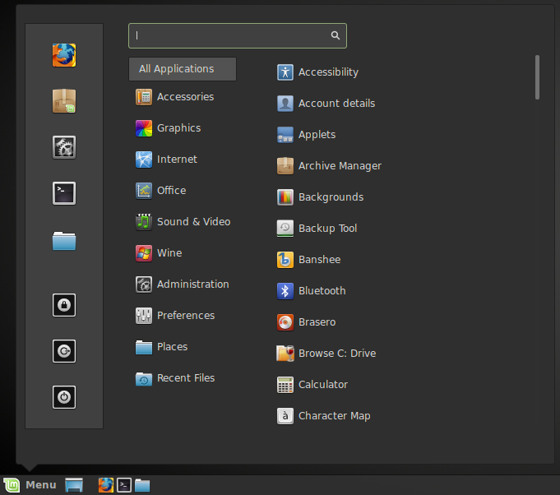
The menu itself has a simple yet elegant layout. At the right, your “Favorites” are located. This are applications you can pin for easy access. To do that simply right click on anything in the menu and some options will appear.

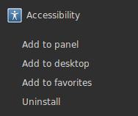

The option are:
- “Add to panel” – will pin the application on the panel. By default Firefox, terminal and the file manager are pinned;
- “Add to desktop” – create a shortcut on the desktop;
- “Add to favorites” – add the shortcut to the Favorites bar in the menu;
- “Uninstall” – easily uninstall the application.

In the Favorites section, bellow the pinned applications, the “Lock Screen”, “Logout” and “Quit” are located.
- The “Lock screen” button locks your screen. A password will be asked to unlock. It is also possible to lock the screen by pressing CTRL+ALT+L;
- The “Logout” button launches a dialog which lets you logout or switch users;
- The “Quit” button launches a dialog box which lets you choose what you want to do:
  - “Suspend” saves your session to RAM and your computer goes to sleep until you press a key;
  - “Hibernate” saves your session to your hard drive and your computer shuts down;
  - “Restart” restarts the computer;
  - “Shut Down” turns the computer off.

At the right of the Favorites section, the “Categories” section is found. At the the top is “All Applications” where everything is located. The other categories exist to easily find specific applications such as Firefox in “Internet”.

When the user hovers the categories, the contents are displayed at the right. A scrollbar also exists for scrolling up and down, but it can also be done with the mouse wheel, or the intelligent scrolling in the menu by simply hovering at the bottom of the menu (It can be disabled; Look in the menu configuration bellow).

At the very top of the menu a “Search” bar is located. Simply open the menu and type. There is no need to select the search bar yourself.

The “Recent Files” contains the last opened files and it can be disabled in the settings. Look in the System Settings → Privacy.

The “Places” represent the bookmarks in the Nemo file manager. It can be disabled. Look in the menu configuration bellow.

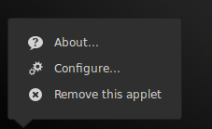
The menu can be opened by clicking on the “Menu” button or hitting the SuperKey (the windows key <the key next to alt>). It can also be opened by hovering it if the option is enabled. To enable that option right click on the menu → click “Configure” → in the opened window choose “Open the menu when I move my mouse over it” option. Further information can be found in this document.

The menu configuration

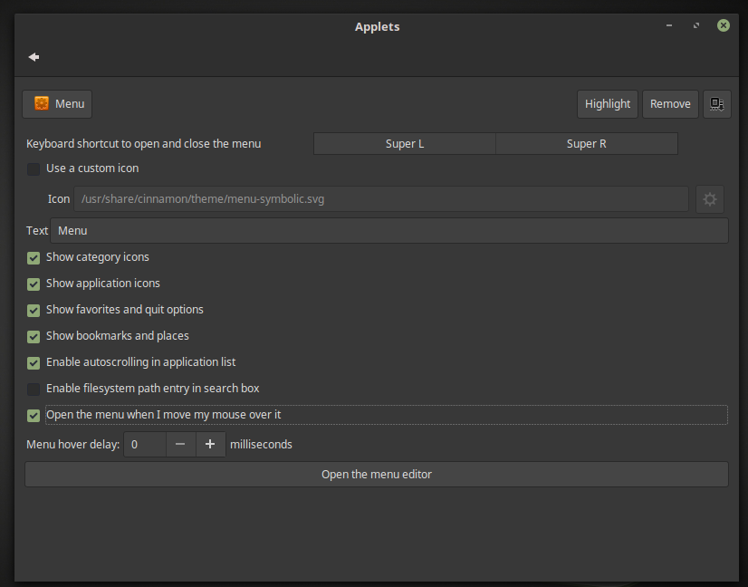
In this menu a few options can be tweaked:
- what keyboard shortcut is used to open the menu;
- the use of a custom icon. Choose “Use a custom icon” and add the path to image file you want to use. It does not have to be a specific format;
- what text to be displayed next to the icon. By default it is “Menu”;
- “Show category icons”;
- “Show application icons”;
- “Show favorites and quit options”;
- “Show bookmarks and places” - told you you can remove it;
- “Enable autoscrolling in application list”;
- “Enable filesystem path entry in search box” - search by path;

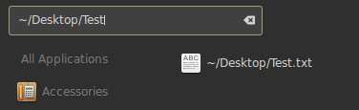

- “Open the menu when I move my mouse over it” - open on hover.
  - You can also select the delay for the menu to open.

The menu editor

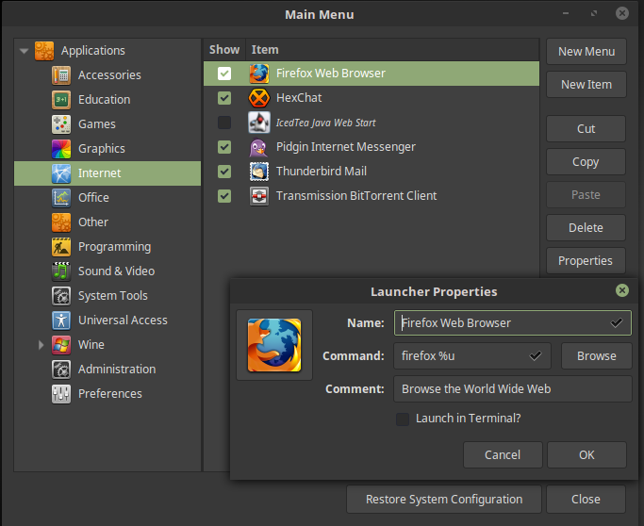
For advanced tweaking there is the “Menu Editor”. It has the following options:
- hide/show categories;
- hide/show applications (for example Firefox will appear in the menu but IcedTea will not);
- create new categories and items in the menu (applications/commands);
- copy/cut/delete applications or categories and move applications in other categories;
- properties of selected items;
  - “Name” – the name that will appear in the menu;
  - “Command” – what application will be opened (please note that in linux every application is a command). Also specific commands can be added for example “firefox -p PROFILENAME” (will open a secondary firefox profile named PROFILENAME; as a side note, to create that profile open the terminal and copy this command “firefox -p”, hit enter, and create new profile);
  - The “launch in terminal” will open the application in a terminal; useful for troubleshooting;
  - This options will have to filled in when creating a new item.
- In case you really mess up, the “Restore System Configuration” option can be really useful.

The Panel

The panel is the bar at the bottom which contains so called “Applets”.
Please note that the panel is not red/green/blue, but the “edit panel mode” is on which allows to move applets around. The green portion allows to move applets in the middle of the panel itself.
The applets are not limited to the ones mentioned, actually there are more. To add more right click the panel.

Right clicking on the panel shows a few options:
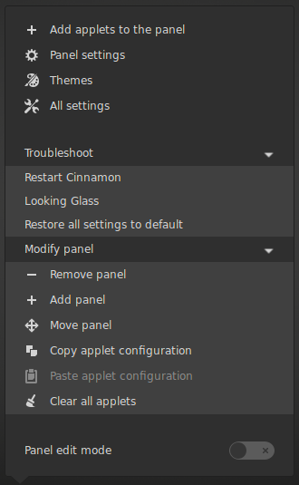
- The panel edit mode is at the bottom which was activated in the previous image;
- “Modify Panel” is a drop down with more options such as:
  - “Remove panel”;
  - “Add panel” - at this time Cinnamon DE only allows for 2 panel one at the top and one at the bottom. I cannot say anything about multiple monitor configurations;
  - “Move panel” - at the top or bottom;
  - “Copy applet configuration” - in case you want a second panel with the same applets on;
  - “Clear all applets” - will delete all applets.
- “Troubleshoot” is a drop down with more options such as:
  - “Restart Cinnamon” - which will only restart the Desktop itself not the computer. It can be done with a shortcut as well : Ctrl+Alt+Escape.
  - “Looking Glass” - is a debugger. Don't mess with it;
    - in ~/.cinnamon/glass.log you can find some info as well for troubleshooting;
    - The ~ means your home (/home/yourusername).

  - “Restore all settings to default” - it can be very important sometimes.
    - gsettings reset-recursively org.cinnamon – this command does the same thing if you can only open a terminal;
- “All settings” - open System Settings;
- “Themes” - open System Settings → Themes;
- “Panel settings” - will open up System Settings → Panel;
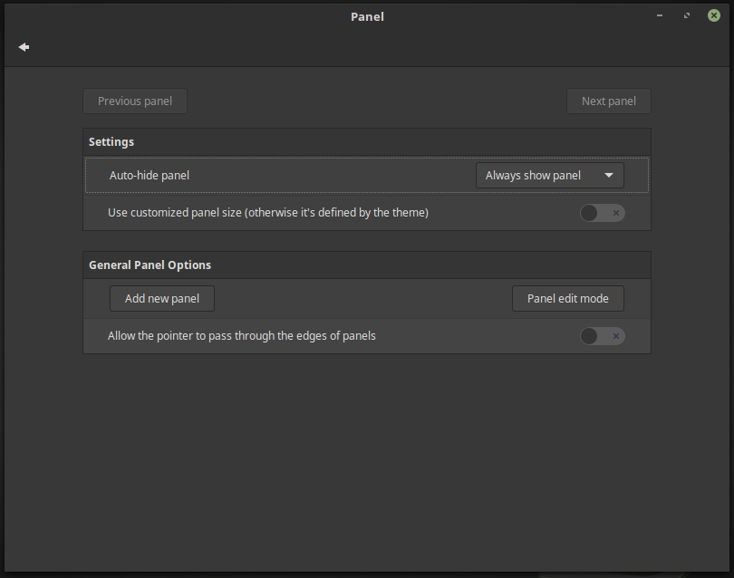
  - Here we have a number of options:
    - “Auto-hide panel” - which can be set to “Always show panel”, “Auto-hide panel” and “Intelligently hide panel”- are the hide options; the show/hide delay can also be set.
    - “Use customized size” - change the size of the panel;
    - “Adding new panel” and the “edit mode” can also be changed here;
    - “Allow the pointer to pass through the edges of the panels”;

The Applets

To add more applets you can go to the System Settings (is in the menu; and Applets itself is in the menu) or right click on the panel and choose add applets.
The panel contains a few applets by default. From left to right we have (the important ones; hover them for the names):
- The menu;
- “Show Desktop”;
- “Application Launchers” - this is where the “Add to panel” sends the applications;
- “Window list” - what you have opened at the moment. At this time there is no “Icon only” version, but it displays an icon and the name of the application;
  - for an “icon only” window list you can take a look at the following user applet: https://cinnamon-spices.linuxmint.com/applets/view/16
  - how to install it can be found bellow. How to install applets.
- “Network manager” - internet;
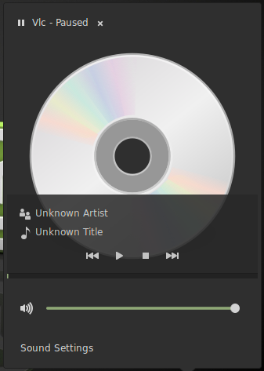
  - it will show if you are connected or not and if you are using an cable or wifi. See Networking.
- “Sound”;
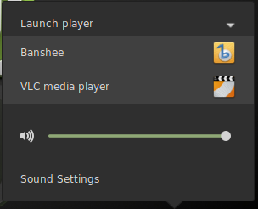

  - you can launch different music players from the applet itself and control the volume;
    - If you do that and play something the icon for the sound will change in a key note and if you click on it, will display the name of the artist, the name of the song, the cover (in this case there is none because is just a test) and easy to access play/pause/next buttons.
  - as a little trick if you hover the applet and move the scroll wheel up or down (also the case with brightness) you can change increase or decrease the sound (by 5%); this is the case up to 100% (150% is max);
  - if you click on the Sound Settings the following window will appear:

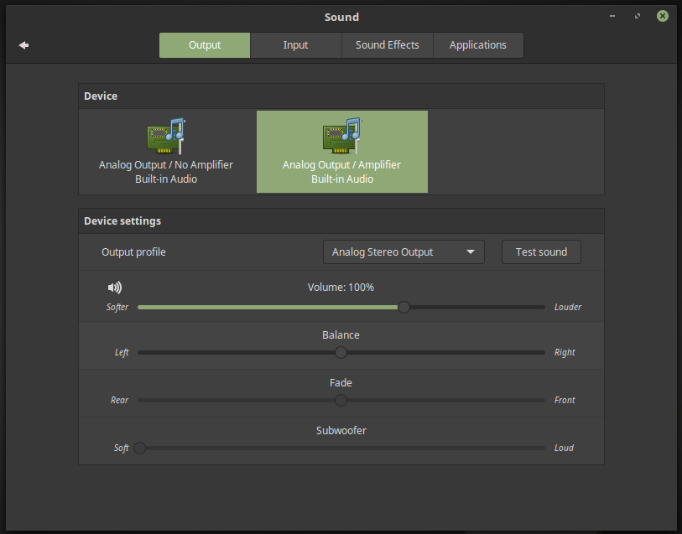

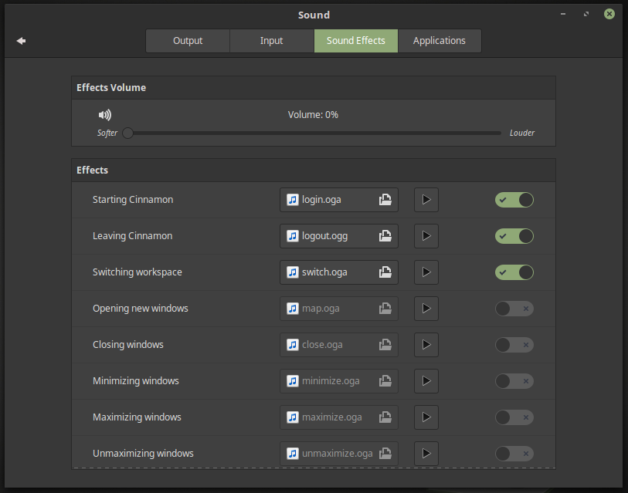
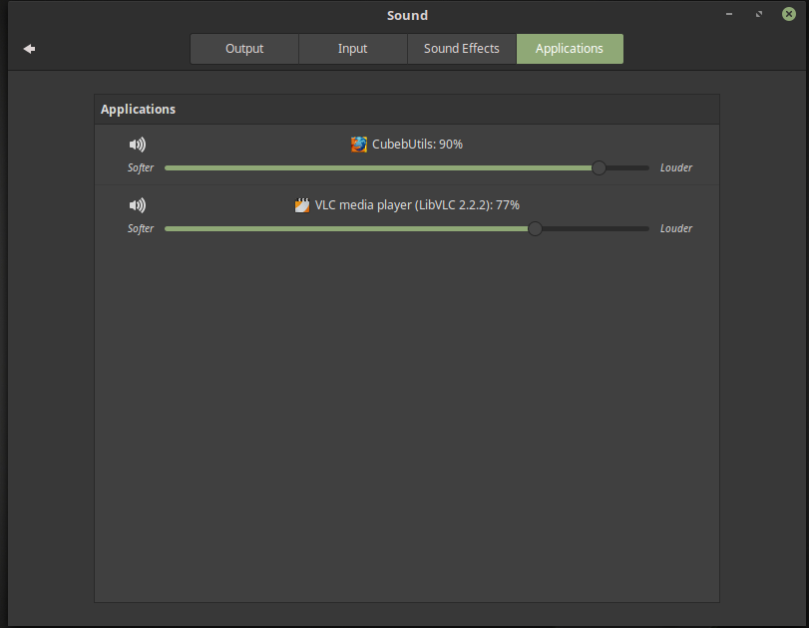
  - in the “Sound Effects” tab you can customize all the sound effects the Cinnamon makes. By default Cinnamon has sounds for everything but you can change them if you want;
  - in the “Applications” tab you can individually change the volume of different applications;
  - “Output” and “Input” are more for people who want exact control over speakers and microphones.

- “Notifications” - where the update manager icon is located;

Linux Mint comes with a tool called the Update Manager. It gives more information about updates and lets you define how safe an update must be before you want to apply it. If you place your mouse pointer on top of it, it will tell you either that your system is up to date or, if it isn't, how many updates are available.
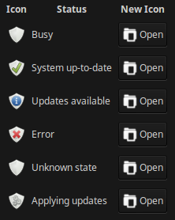

If you click on the lock icon, the Update Manager opens and the first time it will ask you which update policy will best suite you. Please read the options carefully and choose one.

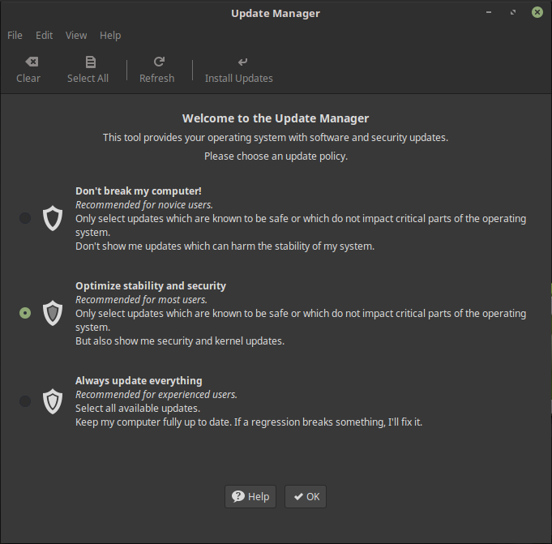
Then you get the actual update screen. You are asked if you want to switch to a local mirror for your updates. Everywhere in the world there are organizations that want to help Linux Mint to spread updates in order to give users the best experience when downloading or updating packages. For the fastest updates select a mirror near to you. If you don't want to use a local mirror then you can change this under Edit-Preferences (this is called the “Software Sources”).
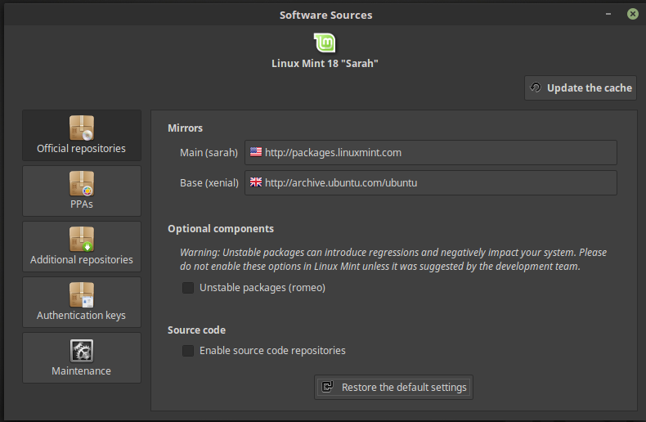
To change the mirrors click on the main and base. A pop-up will appear which will arrange the mirrors by speed.
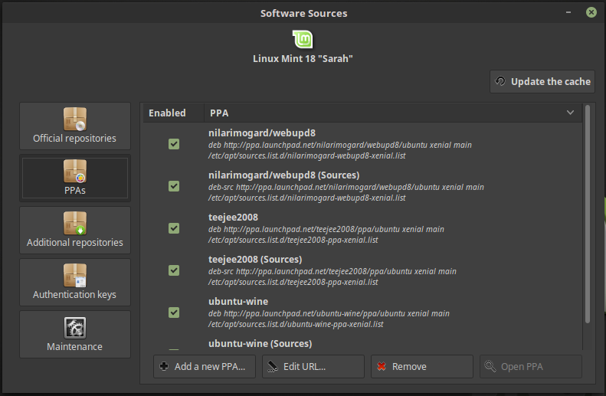

In the PPAs tab you can manage the PPAs you have. These are additional repositories of sort.
- You might want to add PPAs because software is not found in the Software Center or because you want to have the latest version.
- For example to install the latest version of wine you can add a PPA which will keep wine up to date even if in the Software Center it is not.
  - sudo add-apt-repository ppa:ubuntu-wine/ppa && sudo apt-get update

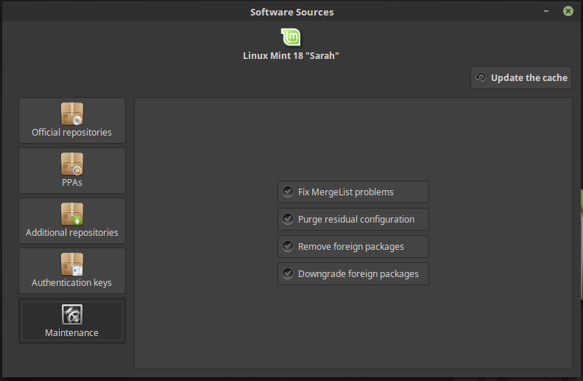
In the “Maintenance” tab there are a few commands you can issue to clean or fix installed packages.
- There are commands in the terminal to manage installed software as well. Because we are here why not take a look.
  - sudo apt-get autoclean && sudo apt-get autoremove
    - this will clean orphan packages and configuration files left behind.
  - sudo apt-get install -f
    - this will try to fix broken dependencies.
  - sudo apt-get install PROGRAM
    - to install PROGRAM run this command.
  - sudo apt-get purge --auto-remove PROGRAM
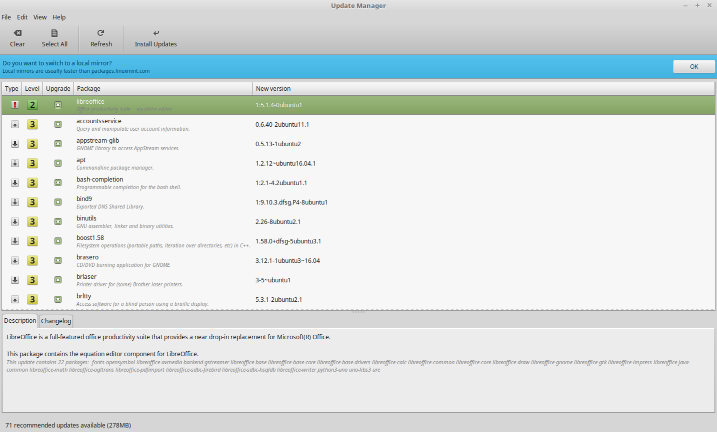
    - to remove the PROGRAM and it's dependencies and clean the configuration files at once, use this command instead of sudo apt-get remove.

The Update Manager shows you the updates that are available. The interface is very easy to use. For each package update you can read the description, the changelog (this is where developers explain their changes when they modify the package), and eventually if Linux Mint assigned warnings or extra information about the updates. You can also see which version is currently installed on your computer and which version is available for you to update to. Also you have a symbol showing if it's a Package update or a Security update.

To update from the terminal, there are a few commands you can use:
- sudo apt-get update && sudo apt-get upgrade
  - this will update and upgrade the system;
- sudo apt-get update && sudo apt-get dist-upgrade
  - this can intelligently manage updates and you might want to use it;

Finally, you can see the stability level assigned to the package update. Each package update brings improvements or fixes security issues but that doesn’t mean they’re risk-free and can’t introduce new bugs. The stability level is assigned to each package by Linux Mint and gives you an indication of how safe it is for you to apply an update.

Of course you can click on the columns to sort by stability level, status, package name or by version. You can select all updates or unselect all of them by using the “Clear” and “Select All” buttons.

Level 1 and Level 2 updates are risk-free and you should always apply them. Level 3 updates “should be safe” but, although we recommend you take them, make sure you look over them on the list of updates. If you experience a problem with a particular Level 3 update, tell the Linux Mint development team so they can take measures to make that update a Level 4 or a Level 5 so as to warn or even discourage others against applying it. Please note that the level 4 and 5 are important updates for security, even though there is a small chance to cause problems the security holes are far worse.

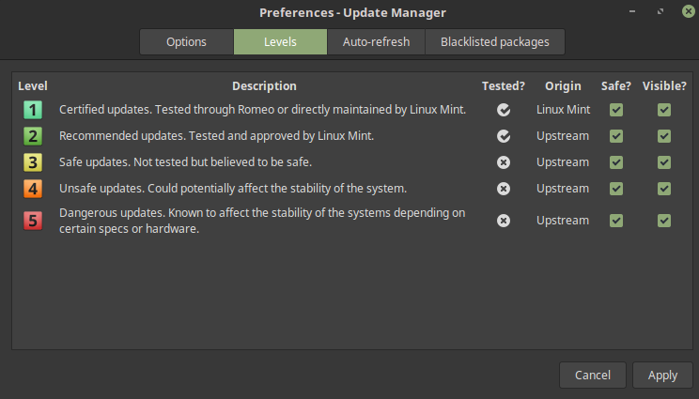
If you select Edit – Preferences - Level you should see the screen above. By default the Update Manager tells you about Level 1, 2 and 3 updates. You can decide to make Level 4 and 5 “visible”. This will make more updates appear in the list. If you want to you can even make Level 4 and 5 updates “safe” (although this is not recommended). This will cause them to be selected by default within the Update Manager.

The Update Manager only counts “safe” updates. So when it tells you your system is up to date, it means there are no updates available assigned with a level that you defined as being “safe”.

The Update Manager only shows “visible” updates in the list.

For example, if you made all levels “visible” and only Level 1 and 2 “safe”, you would see a lot of updates in the list, but the Update Manager would probably tell you that your system was up to date.

The “Options” tab gives you a few choises for tweaking the Update Manager.

Under Options the “Include updates which require the installation of new packages or the removal of installed packages” option allows you to define whether the Update Manager should install new dependencies or not. For instance if package A version 1 was installed on your computer and package A version 2 became available, but version 2 had a new dependency on package B which isn’t installed on your computer… what would happen?

If you left this checkbox unchecked, version 2 would not appear as an update in the list of updates.

If you checked this checkbox, it would, and if selected it would install package B as a dependency.

Be careful with this option as dependency can install new packages on your behalf but they can also sometimes remove packages you already have installed.

The “Auto-Refresh” tab allows you to define how often the Update Manager checks for updates.

In the “Ignored packages” tab you can define packages for which you do not want to receive updates. “?” and “*” wildcard characters are supported.

The “Icons” tab lets you change the icons used by the Update Manager in the system tray.

If you get errors with the Update Manager (“Can’t refresh list of packages” for instance), you can check the logs. Right click on the lock icon in the system tray and select “Information”. The following screen appears:

In this screen you can see the process ID of the Update Manager, whether it's running with user or root permissions, and the content of its log file.

You can also review the updates that were applied on your system (provided they were applied via the Update Manager) by clicking on “View->History of Updates”.

Linux kernel

In the update manager (click the shield in the panel) click “View” and then choose “Linux Kernels”.

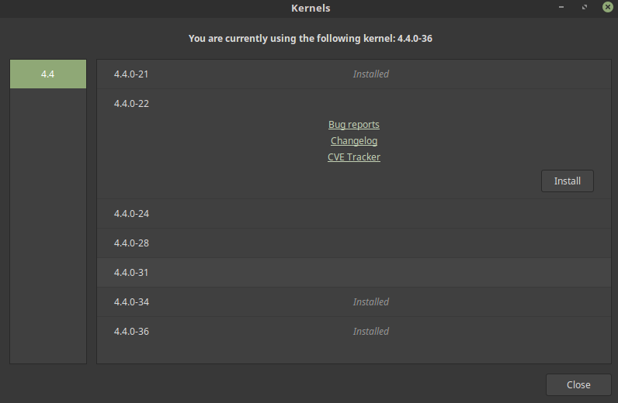
Simply click on “Install” in order to install any other kernel. Please note that the kernel is a very important part of the system. Linux Mint will tell you what kernel is recommended, but in order to remain fully secure or fix an issue you may want to install a newer kernel. After this you must restart the computer in order for the kernel to be used. To see what kernel you have (you can also see it in the window itself), open a terminal and type: uname -a
In case you want to revert to an older kernel, during the boot up of your system Grub will appear (this allows you to select what os to choose; if it doesn't appear press shift). Go to advanced and open Mint with another kernel. Than you can remove the newer kernel.
For more Grub info visit: https://wiki.archlinux.org/index.php/GRUB/Tips_and_tricks

Driver Manager

This is an administration setting so it will require your password (System Settings → Administration → Driver Manager). This is an easy way to install drivers for your computer. You may not need to install anything which is fine, that means all drivers you need are in the linux kernel. In case you are running linux in a virtual machine please go to “Devices” and choose “Insert quest additions”.

- “Calendar”(/Clock); (we are back to applets)
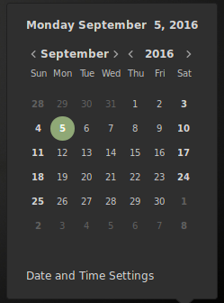

  - by default it showa the time based on the settings you chose during the installation progress;
  - on a simple click it displays a calendar;
  - “Date and Time Settings” can also be opened from here as well as from the System Settings.

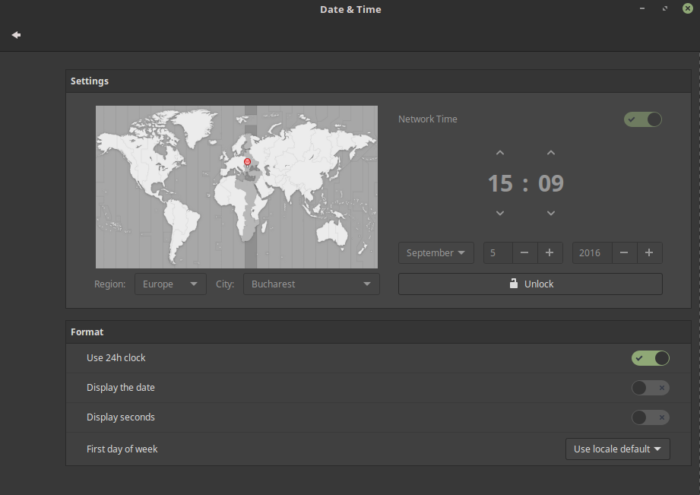
  - In the “Date and Time Settings” you have the following options:
    - change the region and city – useful if you move abroad for example;
    - change the clock from 24h to 12h;
    - choose the first date of the week (Monday for example);
    - display the date and the seconds in the panel;
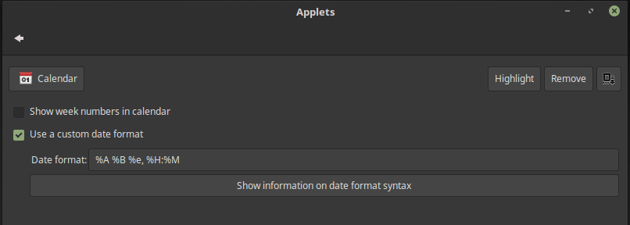
      - this can also be adjusted in more depth by right clicking on the applet → configure;

      - here you can create a custom date format of your liking. For example: %e/%m/%y %H:%M:%S will show 5/09/16 15:25:52 (so date and the hour, minutes and seconds);
      - click on “Show information on date format syntax” to open a webpage with more information.

- “Window quick list” - displays all opened applications in a menu.
- Now, for more applets we can go to “Applets”. Right click on the panel and choose “add applets”. This will appear:
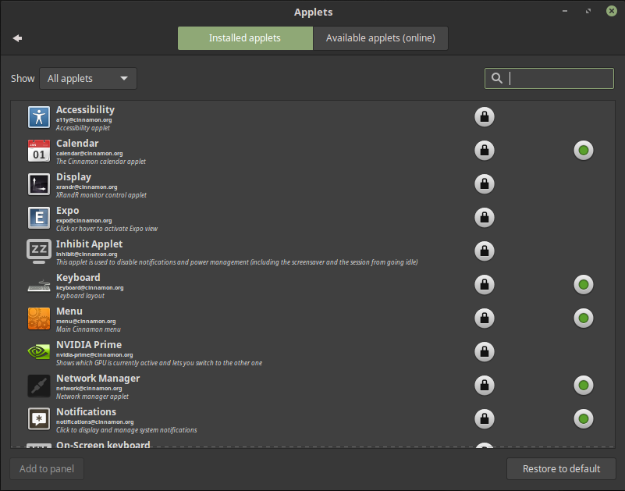

We can sort this applets by active, inactive or all and we can search for anything we like. You can see that green icon right? It shows which applet is on the panel already. The lock is there to show that you cannot uninstall this applets because they are official (you still can remove it, if you know how).

Right click on one and you can add it to panel or remove it (or even unintall it).
Certain applets also have a configure option, which is at the bottom of the window. If you click that we can set some advanced options like we did above for the calendar applet.

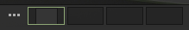
Now, there are too many of them to look at each in detail so (until someone else goes trough the trouble to mention everything) here are a couple more that are useful:
- “Expo” and “Workspace Switcher”
  - the 3 dots are expo;
  - the 4 squares are the 4 workspaces you have;
  - as you can see in the first workspace there is another square, that is a live presentation of the active window in that workspace;
  - if you click expo this will appear:

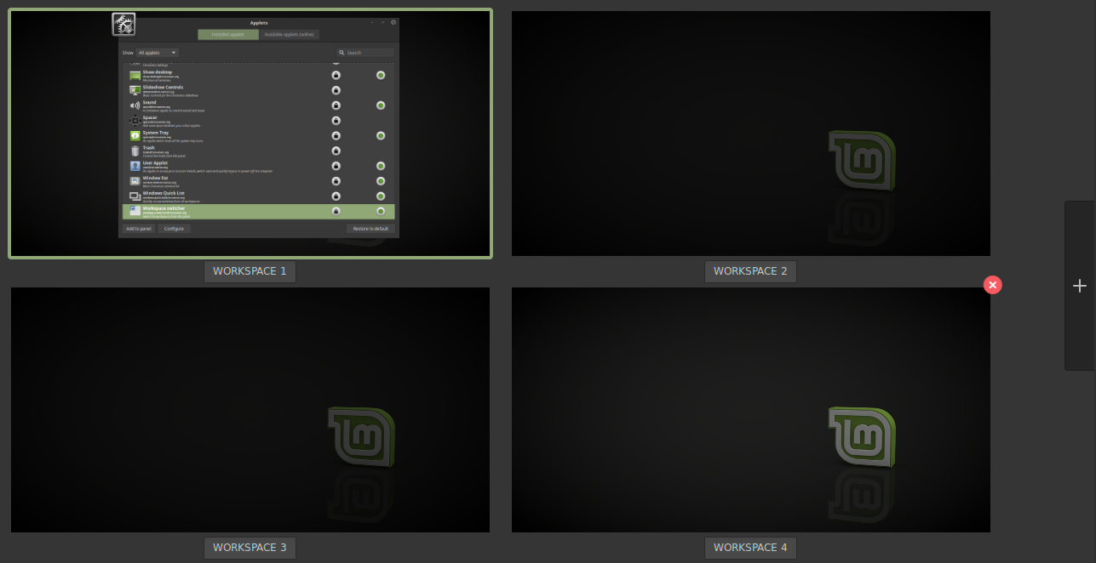
    - in here you can see 4 workspaces which are like 4 virtual screens;
    - in the first one there is that opened application;
    - the others are empty at that moment;
    - you can drag and drop windows from one workspace to another;
      - you can also move an application from one workspace to another by right clicking the active tab of that application (which it is in the panel) and choose “Move to another workspace”;
      - you can also make it visible on all workspaces;
      - other options include
        - “Minimize”;
        - ”Maximize”;
        - ”Close”;
        - “Close other” - this will close everything else except that application;
        - “Close all” - will close everything including that application.
    - if you click on any application you will be move to the workspace it is on;
      - you can also use CTRL+ALT+left/right arrow key to move around;
      - CTRL+ALT+up shows expo mode;
      - CTRL+ALT+down shows only the applications on the current workspace (an overview);
      - ALT+TAB will do something similar to an overview but is a bit different;
    - if you hover an application and click the mouse wheel, that application will close;
    - each workspace has a name. You can change that by clicking it and renaming it;
    - at the top right corner there is a “Close” button which will delete an workspace;
    - at the right edge there is “Plus” button to add more workspaces;
    - to manage workspace in another way go to System Settings → Workspaces;

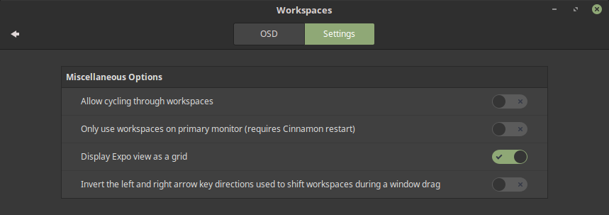
      - here we can change a few settings. For example if you choose not to display expo as a grid (in the example before there were 4 workspaces in a 2x2 grid) then they will show up in a line;
      - as a side note if you install a program called Brightside (sudo apt-get install brightside; and then in a terminal type brightside-properties) you can even move from one workspace to another by hovering the edge the screen and even drag and drop windows like that. (Side side note: make this a function of Cinnamon, Mint Team)
- and in case you need more applets, go to “Applets” → “Available applets (online)”;

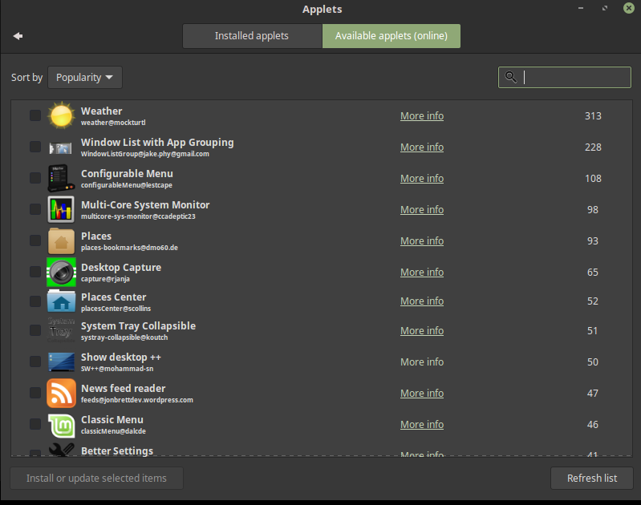
  - if you click on that little square to the left of the icon you will select the applet for installation, then click “Install or update selected items”;
  - click “More info” this will open up Cinnamon Spices, where that applet was uploaded;
    - if you want to download an applet from here instead : download it and decompress it in ~/.local/share/cinnamon/applets.
      - As a side note the official applets are in (delete to remove them) /usr/share/cinnamon/applets
      - This is where you can delete if you want to;
        - To go deeper in this, an applet usually has a .js file where the code for what it does is, and a .json file where some info about it are (and settings if that applet can be configured). For example: "uuid": "calendar@cinnamon.org", "name": "Calendar";
        - You can copy the calendar applet for example in the ~/.local/share/cinnamon/applets, change the folder name to something like mycalendar@me and to the same in the .json file. ("uuid": "second-launcher@me", "name": "Second launcher");
        - All of that said, you can make your own applet if you know how to and use it in Cinnamon. Now, if you are also a nice person maybe share it on Cinnamon Spices so others can use it.
    - in this site you can also find themes, extensions and desklets. So we will talk about them now.

The Desklets – phew another section, finally.

To access “Desklets” go to System Settings → Desklets (or if you didn't notice you can search for it in the menu)

If you understood what applets are, well desklets are the same but on the desktop.

You can also download additional ones from the internet like the applets. To install a desklet manually: download it and decompress it in ~/.local/share/cinnamon/desklets

Desklets will conform with the theme of the desktop. More settings can be found in the 3rd tab called “Settings”. If you chose no decoration for theme they will have no background, which you may like or not. The header will show the name of the desklet. Note that the theme you have also dictates how applets look.

As a side note there is something called “Conky” which acts like a desklet but can be more advanced. To install it:

sudo add-apt-repository ppa:teejee2008/ppa
sudo apt-get update
sudo apt-get install conky-manager

In the menu you can find “Conky Manager” and choose what you want from there. There are also more conkys on the internet like on DeviantArt.
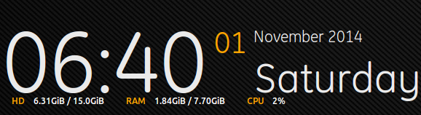
Here is standard conky (you can modify the code in any way you want)

Conky can also be extra heavy on visuals and make your desktop look like a futuristic PC. Go nuts!

The Themes

Ah, one of the most important things to some people (me included). If you noticed I have used the Mint-Y-dark (waiting for the blue variant Mint Team).

To open Themes go to System Settings → Themes (or search in the menu, or right click on the panel).

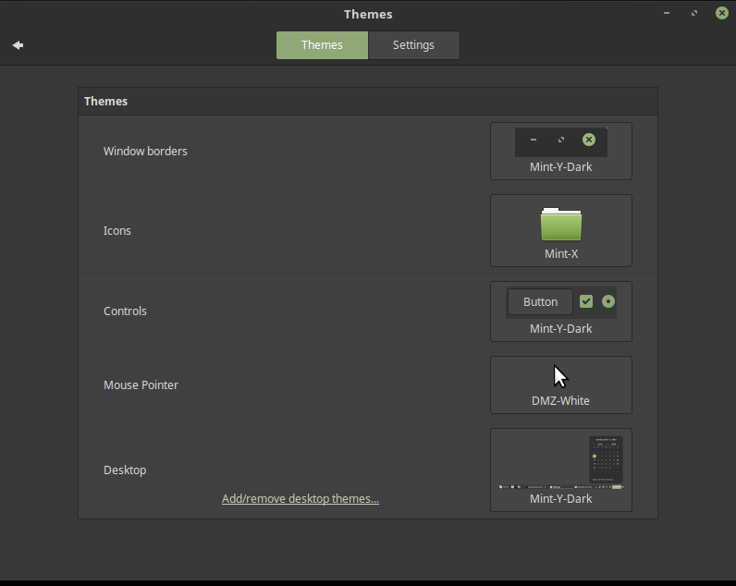
Cinnamon DE has all you need in one window:
- “Window Borders” - the borders around the window you grab to resize and the header above with the name of the window opened and minimize, maximize and close buttons;
- “Icons” - what icons are used for the folders, applications in the menu, applications in the settings (if they are any) and action icons (the panel icons, the button icons in the context menu <right click>, in the drop menus <file, edit etc>, in the file manager and in some applications like Audacious or Firefox; still waiting for a dark theme friendly action icons Mint Team instead of the black ones);
  - the global icons are in /usr/share/icons – here the default icons from Mint are located;
  - your personal icons are in ~/.icons – you may have to create it.
- “Controls” - the name doesn't tell you what they are but this is basically all the backgrounds in the file manager and applications. This is what you want to change if you want a dark theme. This is gtk based.
  - the global themes are in /usr/share/themes – here the default themes from Mint are located;
  - your personal themes are in ~/.themes – CTRL+H to see it;
  - additional themes can be installed the same way as applets and desklets. Click on “Add/remove desktop themes”:

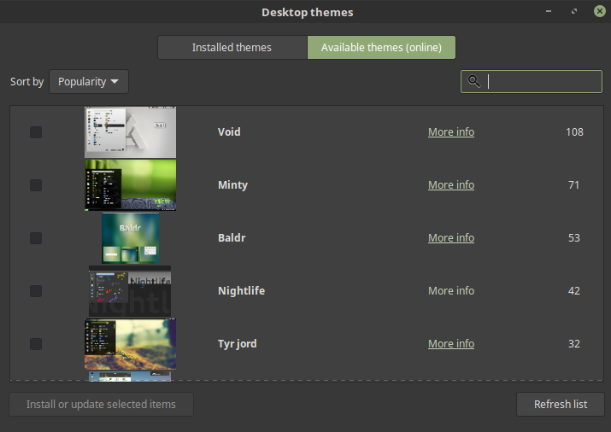
  - now, some of this themes are only for the Cinnamon Shell (Desktop) and other are for the controls. Some times they are for both.
- “Desktop” - is what the panel and the menu look like.
  - if you open up a theme folder inside you will see a folder called “cinnamon”, that is it;
  - the “gtk*” folders are for the controls. If you have a gtk theme it most likely not look nice with KDE applications.
  - the “metacity-1” folder is for the borders;
  - “index.theme” has some information about the theme. It is the same for icon sets, but in that case it also mentioned “Inherits” which means that in case an icon is missing than use the inherit icon set. This also is done to have Mint-X-Aqua, for example, only as folders but inherit the rest from the main Mint-X.
- “Mouse Pointer” - your cursor; additional ones can be installed by putting them in the ~/.icons folder.

For more icons/themes/cursors you can also visit websites like:
- https://www.cinnamon-look.org/browse/ord/latest/
- https://www.gnome-look.org/browse/ord/latest/
- https://www.xfce-look.org/browse/ord/latest/
- https://www.kde-look.org/browse/ord/latest/
  - I mention kde-look but keep in mind that most things for KDE won't work in Cinnamon. That is possible if you take things for gnome or xfce as well.
- http://www.deviantart.com/
  - You can also find some nice stuff here, but you do need to search for it.

A few more settings are in the settings tab of “Themes”:

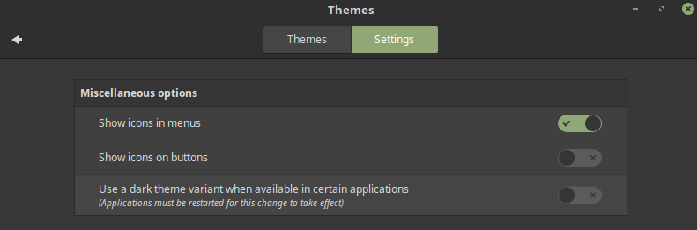
“Show icons in menus” means to show icons in the context menu (right click) and in drop down menus (files, edit etc).

The Extensions

To open Extensions go to System Settings → Extensions (or search in the menu).

The Extensions represent extra features you can add to the desktop. To understand better let's have a look.

To install an extension select it and click install (at the bottom of the window) or click more info, download it and extract it in this folder: ~/.local/share/cinnamon/extensions

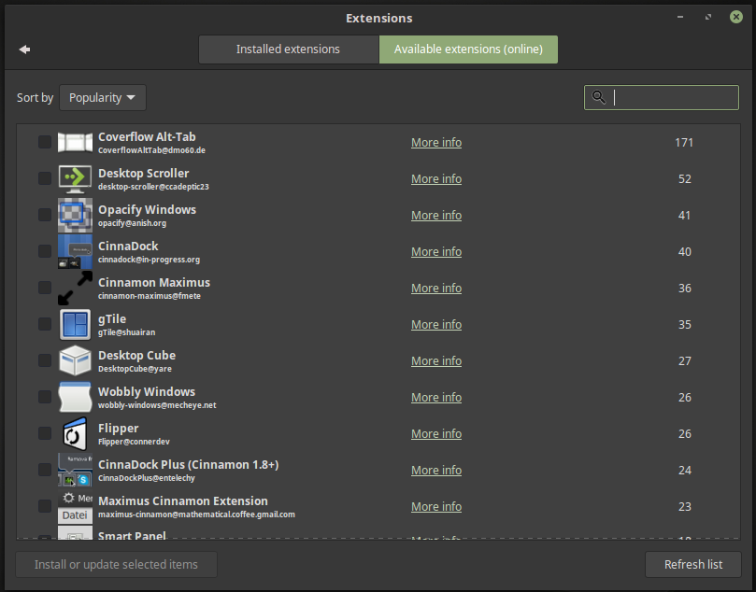
Now, not everything here will work, because extensions are not official but fan made. This extensions will allow, for example, transparency in windows or different effects/animations that are not present in Cinnamon by default. Let's have a look at “Smart Panel”. Install it and go to “Installed Extension” tab. Right click on the extension and choose “Add to Cinnamon”, that's it. You will get an warning screen : “Extension smart-panel@mohammad-sn is not compatible with current version of cinnamon. Using it may break your system. Load anyway?”

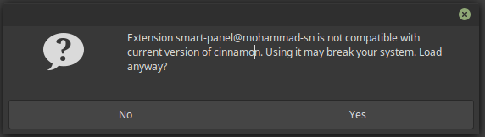
Choose yes. Again it might not work or at worse break something. Your risk.

Smart panel for instance has some nice features such as binding commands to double click on panel, middle click on panel, scroll wheel up/down on panel and more. Play it extensions and see what you like.

Also at the top right corner there is an icons near remove. It will allow to export settings or import settings. Cool right?

The Effects

Because effects/animations were mentioned why not move to those next?

To open Effects go to System Settings → Effects (or search in the menu).

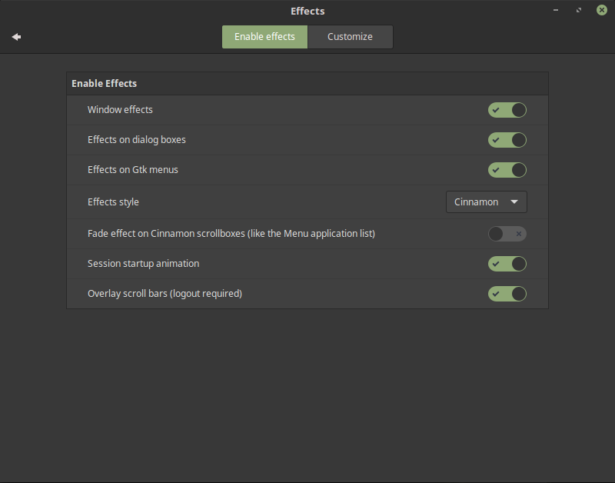
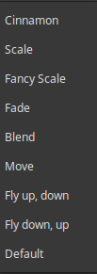

Effects simply represent animations that cinnamon does for things:
- “Window effects” - this include maximize, minimize, close and resize animations;
- “Effects on gtk menus” - on the other hand are effects on menus like the context menu or dropdown menus (file, edit etc);
- “Fade effect on Cinnamon scrollboxes” - this is a menu scroll animation;
- “Session startup animation” - remember when you log in and the desktop kinda pops? Well, that.
- “Effect style” - are some presets of different animations. For instance I prefer “Fly up, down”.
  - You can also customize effects if you want to.

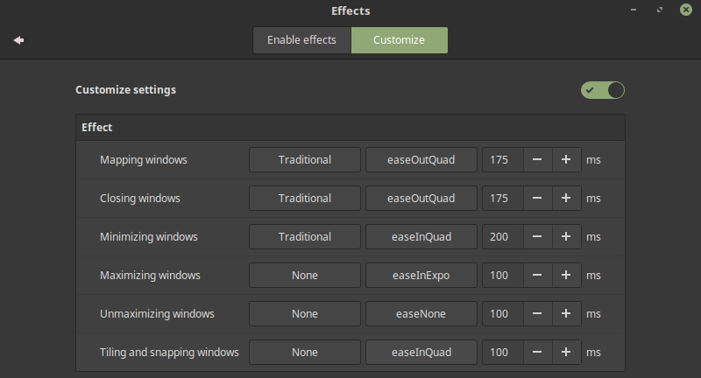
  - Click on traditional and you can choose a different animation. You can also set the time in ms;
  - Mapping means when you open up an application or you unminimize it. The rest are pretty easy to understand.

As a side note, Cinnamon cannot have Compiz or Kwin which are some fancy applications. The reasoning behind this is outside this documentation but I thought you should now if you wanted to have them. Other desktops work with this such as MATE or Xfce.

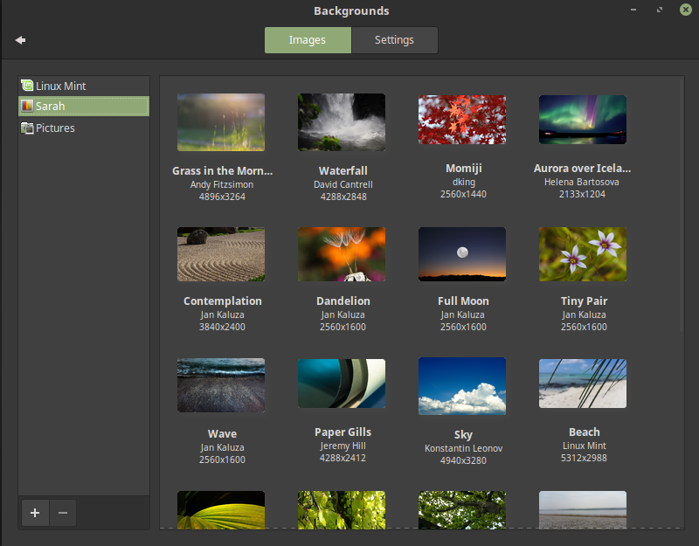
Backgrounds

You can also get here by right click on desktop and “Change desktop background”.

By default Linux Mint has some wallpapers, but in the bottom left corner there is a + button. Click on that and you can add folders here (not images, but folders that contain images). Then just click on any wallpaper and you are set.

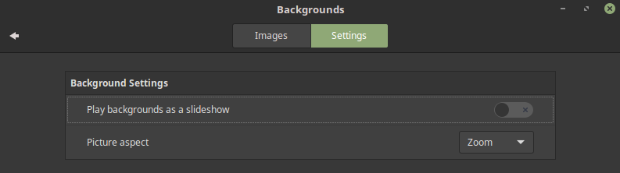
In the settings tab you can also choose “Play backgrounds as a slideshow” which will change the backgrounds from time to time. The delay and order are up to you. The aspect ratio may not be something to play around with unless the image you got is not displayed well.

Now as a side note, Cinnamon cannot have different backgrounds for different workspaces (maybe in the future). For a possible solution: https://forums.linuxmint.com/viewtopic.php?f=219&t=118540?f=219&t=118540#p672189 (may not work)

Fonts
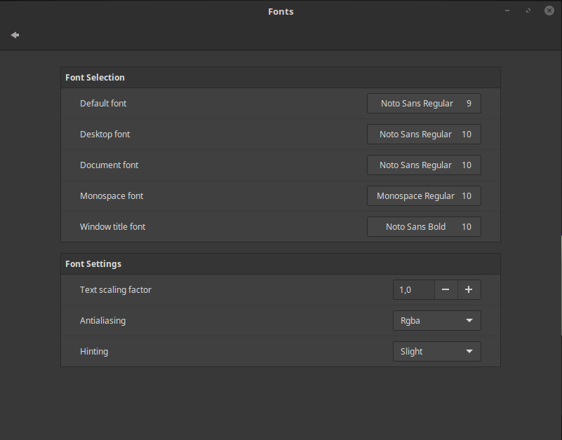

Here you can change the fonts (text) in the system as well as the scaling factor which will make text bigger “Text scaling factor” (useful if you don't see well; also nice to have such an easy way to do it). Antialiasing and hinting are none of most people concern, because The Mint Team has already tweaked this, but if you need to do adjustments (and know why you need too) they are here.

Accessibility

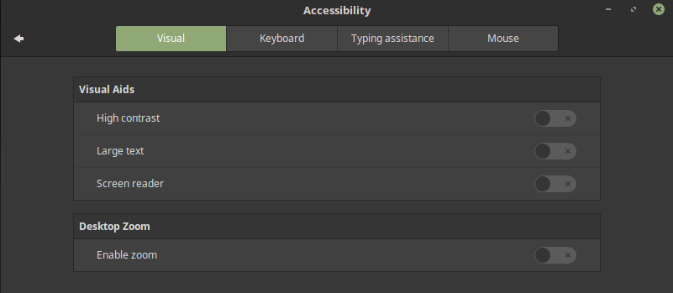
Here you can have some options for people with visual problems. Not only that but the Keyboard (multiple layouts) on screen can even be a nice addition if you installed Cinnamon on a tablet or maybe because you don't have a keyboard. There is also the applet for Accessibility for easy access.

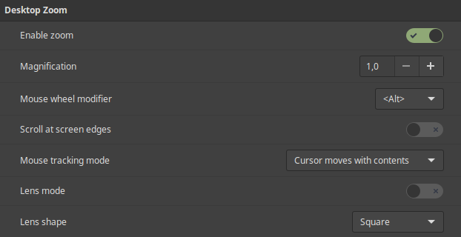
Zooming can be also something you might to take a look at. It can be very useful at times even if don't need it. Also it looks cool. Feel free to play around with this one.

Account details

No picture here because there is not that much. Here you can choose a picture for you account (also add multiple ones), change username and password.

Users and groups

This one is at the bottom of the System Settings and will require the password. I mention this here because it is linked to Account details. Unlike that one here you can actually see all the account on the machine.

As a bonus here you can manage any account, the account types (make sure only one person <you> is administrator) and manage groups. I could just place some commands here but instead here are some videos:
- https://www.youtube.com/watch?v=-76ExmKBPfY&index=12&list=PLT98CRl2KxKHaKA9-4_I38sLzK134p4GJ - Linux Commands for Beginners: 12 - Creating Users
- https://www.youtube.com/watch?v=zyjTMRQo0Mw&index=13&list=PLT98CRl2KxKHaKA9-4_I38sLzK134p4GJ - Linux Commands for Beginners: 13 - Removing Users
- https://www.youtube.com/watch?v=DPzFiAqNl3M&list=PLT98CRl2KxKHaKA9-4_I38sLzK134p4GJ&index=15 - Linux Commands for Beginners: 15 - Group Management

The Desktop

I don't think I need to explain much here. Instead let's look at the settings.

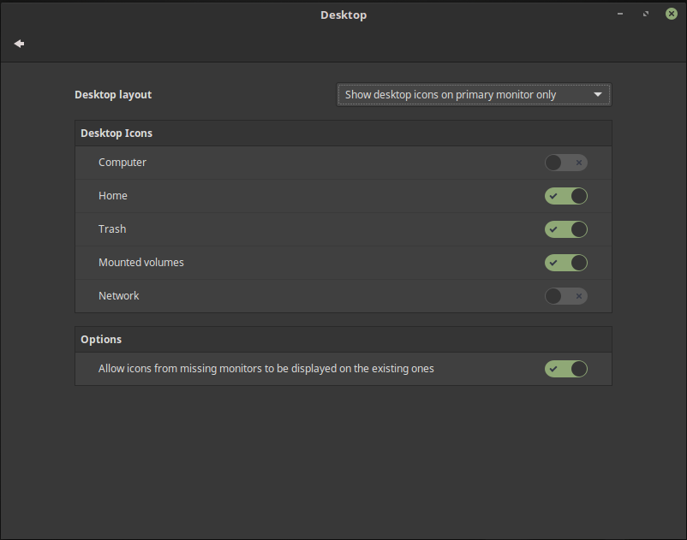

In the System Settings → Desktop. Here we can choose what icons (if any) will be displayed on the desktop. “Computer” will send you to / , “Home” will send you to your home folder, “Trash” is the Recycle Bin in Windows, “Mounted Volumes” are other partitions, drives, USBs etc.

If you right click on the desktop:
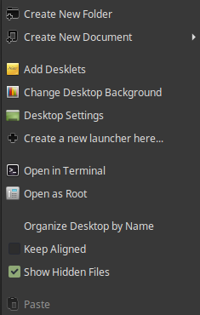
- create new folder will make an empty folder
- create new document will create files;
  - as a side note in your home folder there is a folder called Templates;
  - here you can create additional files such as a “New Word Document.odt” or “New Css file.css” etc. They only need the name and the extension you want. The contents of the file should be empty but if you want to add something you can. For example a template for “Script.sh” will have “#!/bin/bash” inside.
- “Create new launcher here” will open a popup that you have seen before. Insert the name and the command you want, and even an icon in order to have a custom shortcut. Of course when you click in the menu on “Add to desktop”, the menu does just this;
- “Open in terminal” will open a terminal in the desktop folder. This is the same thing as open a terminal than “cd ~/Desktop”. This command is also present on other folders as well;
- “Open as Root” - Root is the “god” of the linux world, or the administrator. When you are prompted to enter your password you basically gain the power of Root for a time. sudo command will run the command as root, that is as administrator. Also have a look at:
https://www.youtube.com/watch?v=Xi-jwoxoTKg
- “Organize Desktop by Name” - will organize the files on the desktop alphabetically;
- “Keep Aligned” - if you activate this icons will snap to an invisible grid and will look nice and clean. If you don't activate it than you can put icons as close to each other as you like (even if there is no space they will stack);
- “Show Hidden Files” - in linux hidden files have a “.” at the beginning of their name: .icons , remember? To show them you can also press CTRL+H;
- As a bonus if you start typing on the desktop files will be searched for you (on the desktop). This is a feature of Nemo, the file manager. What's that? Wait we didn't talk about it yet? Ah well...

Nemo

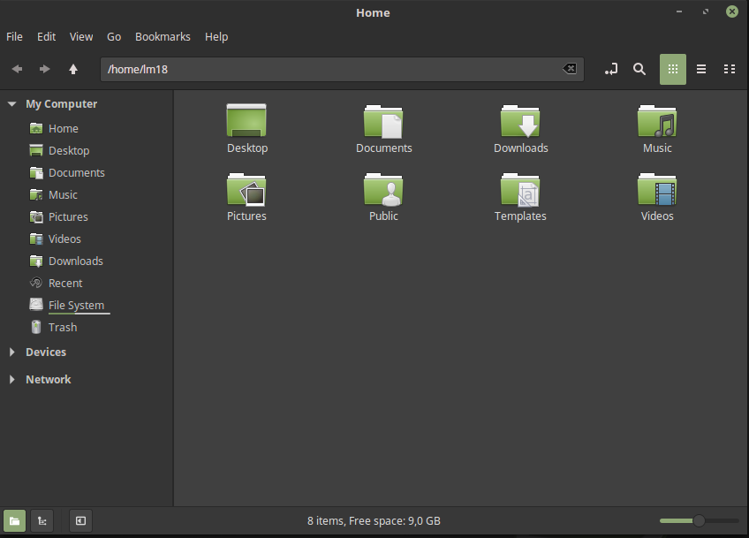
Nemo is the file manager of Cinnamon. You know that thing that looks like a browser but for your files? Just double click on Computer or Home or create a folder.

Let's have a look at your home folder ~ (Every user has a home folder including root). Here you can see some folders like Desktop, Documents, Downloads etc. Pretty easy to understand what they are. CTRL+H also shows more files and folders like .icons or .themes which we talked about and also others which hold all the settings of your account. Yes, linux does hold all your settings in 1 folder and not all over the place. This means if you copy your home folder you can easily keep all your files (upgrading may cause issues though) and if you are like me and you have HOME as another partition (that is if you made it at installation) than by not formating it (erasing it) than all your settings will remain (except anything that requires a password to be done). Nice huh?

Now, Nemo's layout:
- at the top you some drop down menus: File, Edit etc. We'll get there;
- bellow that you see back/forward buttons, and an UP button (go to upper directory or parent directory);
  - that is if you are in ~/Desktop/Folder you will go up to ~/Desktop
    - the / is how linux separates folders unlike Windows which does it backwards \
- to the left there is the path where you are;
  - This will display in 2 ways by clicking on this icon:
  - you can actually type in an address like: /usr/share/icons and go to it.
- to the left you will see a search button which will, search for files in this folder (or “All files” if you choose so);
  - also you can search in the folder by simply typing (like on the desktop remember?).
- then there are 3 icons for different views (also available in the View dropdown menu)
  - icon view – big icons;
  - list view – everything in a list with more information on the right;
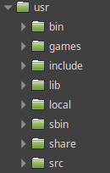
    - in this mode to the left of a folder there is a little arrow. If you click that you will see the contents of the folder;
    - and then you can go to subdirectories and other subdirectories and …
  - compact view – small icons and names, no more info;
  - Nemo also remembers what view you like for what folder too.
- on the left side of the window you can see My computer and some other icons in a tree layout. That's the sidebar. Well here are your “Places” (remember the menu?) - note that “Bookmarks” is a different thing that will show up in the sidebar as well;
  - you can simply click on something and go there;
  - right click on one and you can choose to remove it;
  - to move them just drag and drop;
  - you can drag and drop folders here to have them at hand (create them);
  - in devices will show up the mounted partitions, USBs etc;
  - if you look at the bottom left corner there are 3 icons;
    - the first show the “Preview mode” - what you have seen so far;
    - the second will show a “Tree view” which will follow where you are in the system;
    - the third – hide or shows the sidebar itself;
- at the bottom center you see “x items, Free space : …. “ - a nice touch;
- at the bottom right corner there is a slider to adjust how big icons are. Or do CTRL and + or – or even CTRL and scroll the mouse wheel for the same effect. It works regardless of view.

Let's have a look at file, edit …
- File
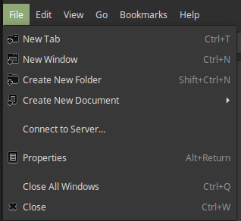
  - it has the option to open multiple tabs, and yes Nemo has multiple tabs.
    - you can also open tabs with the shortcut displayed there (CTRL+T)
    - or open a tab by middle click on a folder;
  - new window will open another instance of Nemo;
  - properties will let you see the properties of the folder you are in;
  - “Close All Windows” will close all Nemo instances, and simple “Close” only this one

- Edit
  - this one has some easy options like redo undo, or move files around or delete them;
  - interesting is the “Invert Selection” which can be very nice when you have to select a lot of files except one or two;
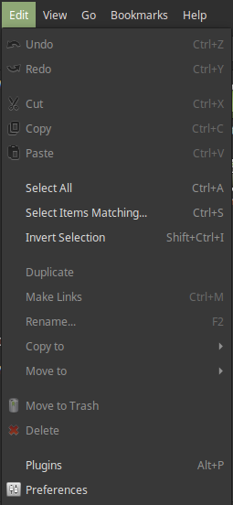
  - If you have a folder selected (that has the Mint-X folder theme) you can actually change their color;
  - Now, if you look at the end there is the “Plugins” and “Preferences”. Let's begin with preferences.

- Preferences
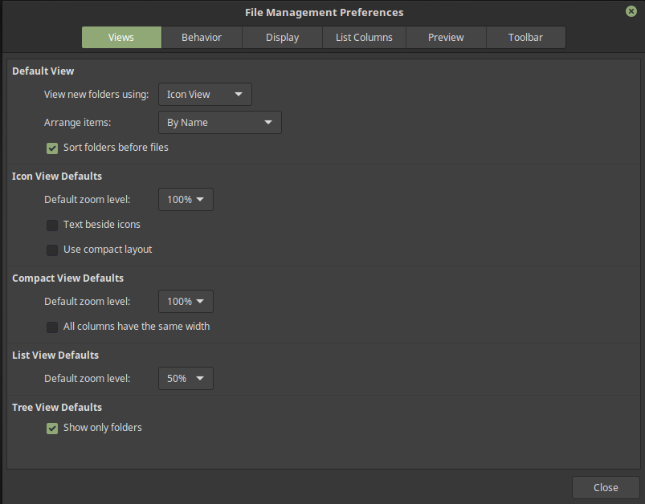
  - In the “Views” tab we can choose what default view mode we want, and how to arrange the items (again default).
  - At the same time we can customize the default settings for other views like the zoom level.

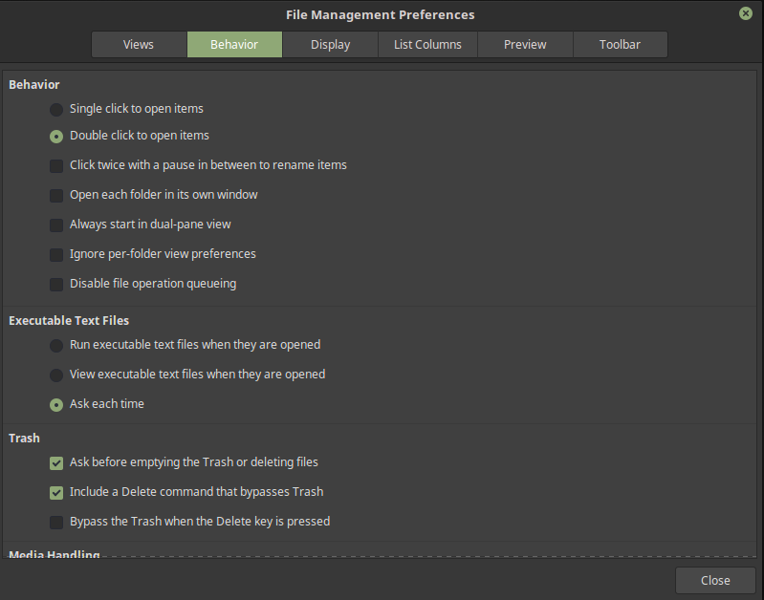
- Behavior

  - if you like to open files with one click or two here is the option;
  - also the 3rd option is very useful for renaming files easily;
    - and at the bottom there is even an option for bulk renaming too;
  - Nemo also has a “Dual-pane view” which looks like this:
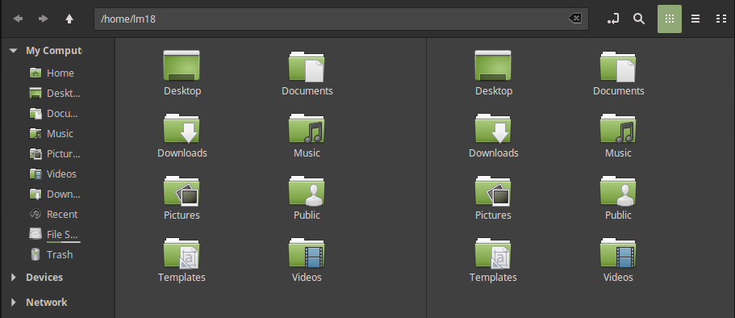
    - in this mode each side is like it's own folder; you can also have different folders in each side.
  - The “Executable Text Files” section is for scripts. Now, I like to “View...” them so I don't need to be asked all the time.
  - The “Trash” section allows you to remove those annoying “Are you sure you want to delete this files…”.

- Display
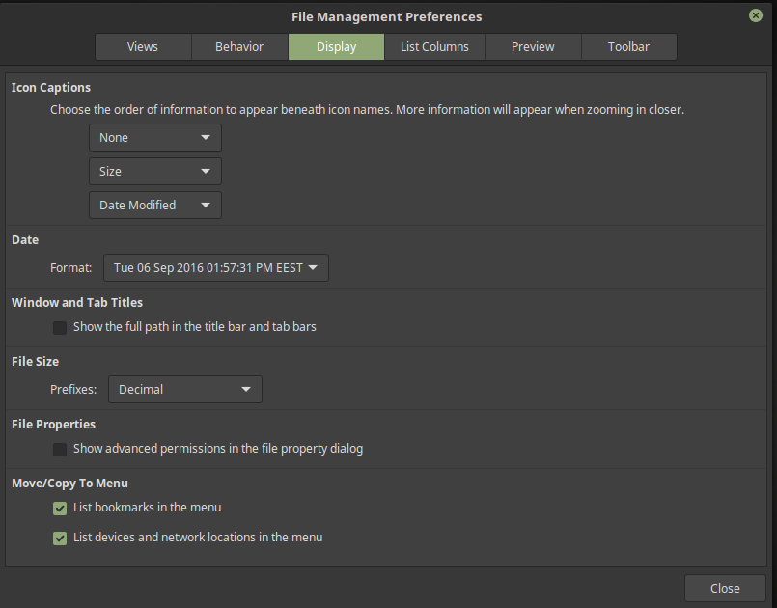

  - in the display tab we can change how Nemo displays some informations. By default it looks nice so don't bother with it.

- List Columns
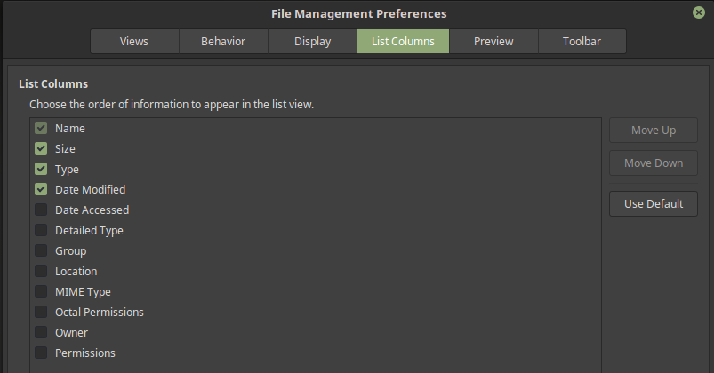
  - choose what info you want to be displayed in the “List view”. That's it.
- Preview
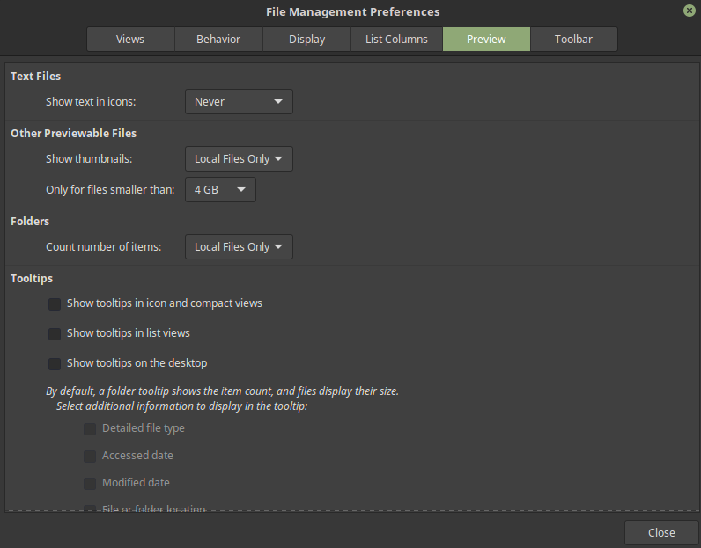

  - the preview options are something that some people have problems with
  - the previews (thumbnails) are handled by Nemo and the video ones by Totem (default video player in Nemo)
  - if you want to actually have any thumbnails choose around 4 to 8 GB in “Only for files smaller than”
  - the tooltips are more annoying than actually useful so maybe leave them alone. The tooltip shows you a big box with some info in it when you hover a folder or file.

- Toolbar

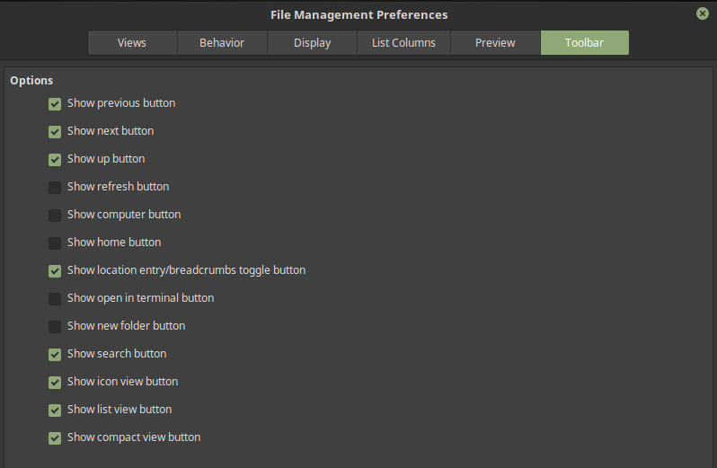

  - the toolbar is where you have the forward, backward, up buttons, the path bar and the views buttons;
  - here you can add some more buttons like “new folder” or “open in terminal” which are useful.

- Plugins

  - plugins are basically some pieces of software that extend what Nemo can do;
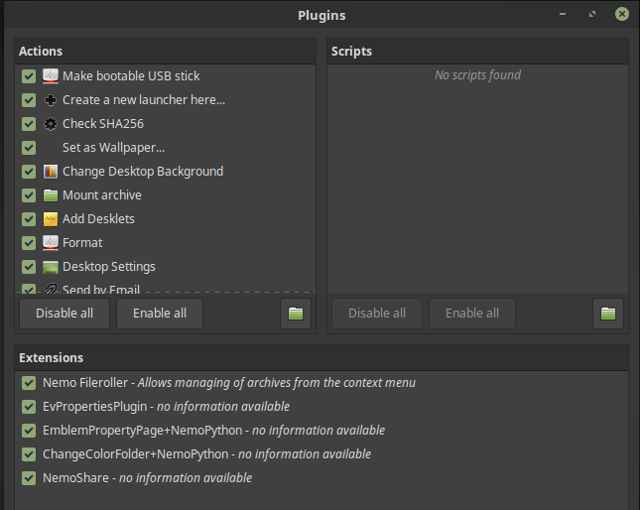

  - there are also extensions too, and scripts;
    - some of this stuff is already made but you can create your own;
  - you can easily enable or disable this stuff;
    - actions/scripts are going to appear in the context menu (right click);
    - if you click that little folder icon, a folder will appear:
      - ~/.local/share/nemo/actions – where the local actions are (that is yours)
        - at the top you are going to see a green bar at the top click “More info”. This will open a file with info how to make an action.
      - /usr/share/nemo/actions – where the global scripts are (the Mint ones; as a side note nice to see a check sum in there, I made my own in the past)
    - extensions (not to be confused with Cinnamon ones) on the other hand are a bit more powerful. They are not just commands but more like actual programs that run in Nemo. For example remember I told you above you can change the color of folders (if they are Mint icons), well that's an extension.
      - more extensions can be found here: https://github.com/linuxmint/nemo-extensions
      - the terminal one can be very useful.
- View – back to dropdowns now
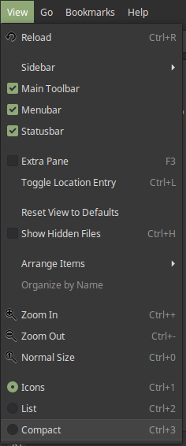
  - here you can reload the folder;
  - choose how the sidebar is displayed;
  - display/hide the toolbar, menubar and statusbar;
  - activate the Extra pane showed above;
  - reset the settings for view;
  - arrange items by name etc;
  - zooming in or out;
  - and what view mode you prefer;

- Go
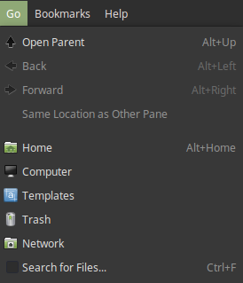
  - this let's you go up, forward or backward;
  - also to different important folders;

- Bookmarks
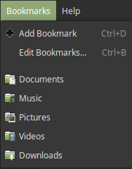
  - bookmarks should not be confused with places;
  - that much difference there's not and I at the very least never even bothered with them, but hey, they are here;
  - they will display as a separate thing in the Sidebar;

- About
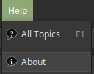
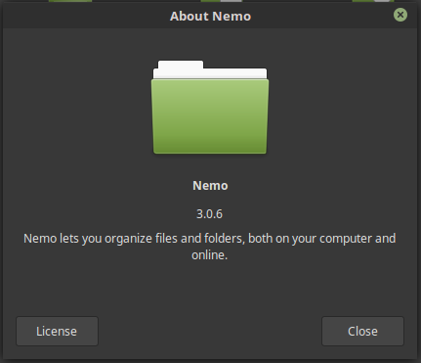
  - if you click on “All Topics” the official documentation will open up in your browser;
  - “About” - will display info about Nemo, such as what version you are using. Same for other applications.

This was not mentioned but Nemo also takes care of your desktop. If you want to you can install other file managers at set those as the default.

Quick, to the Settingsmobile, I mean System Settings.

General

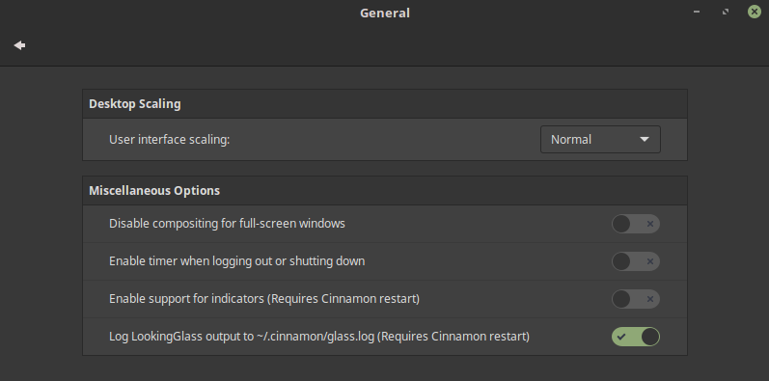
- Here we can find 2 very important options:
  - “User interface scaling” - in case you have a more modern screen (4K) scaling will actually enlarge the windows on your screen so you can actually see something;
  - the login of LookingGlass can be really helpful to troubleshoot things;
  - more minor settings in the timer for shutting down (say wait 30 seconds before the PC turns off).

Hot corners
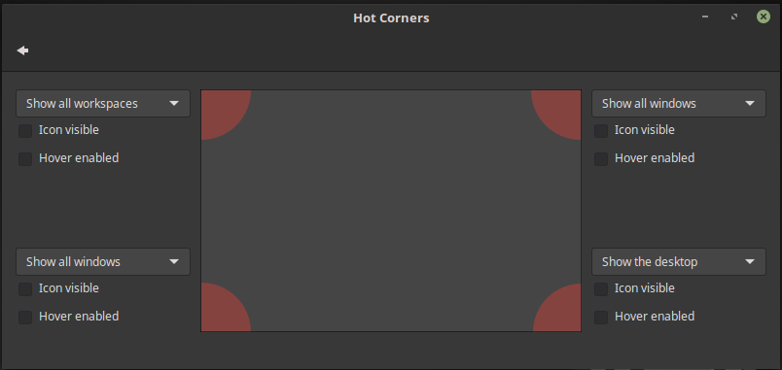
By default Cinnamon has a hot corner option. It is disabled as you can see because it will be pretty weird for something to happen without your knowledge.

Hot corners has a click icon or hover option.

By default there are 4 options you can choose:
- “Show all workspaces” - expo mode, CTRL+ALT+up basically;
- “Show all windows” - is an overview of the programs opened;
- “Show desktop” - minimize everything, you know to hide the fact that you were not working but instead “working”;
- “Run a command” - well basically that. Any command you can issue in a terminal will do:
  - for example you can do this: amixer -D pulse sset Master 10%+ (+ or -) which will change the volume by 10%.
  - or maybe you want to start the screensaver: gnome-screensaver-command –activate
  - or maybe take a screenshot of a selected area: gnome-screenshot -a
  - you get the point;
  - as a side note this doesn't work when for example you are watching a youtube video in fullscreen. Hm, there should be an option for that though (brightside does it).

Languages and Input method

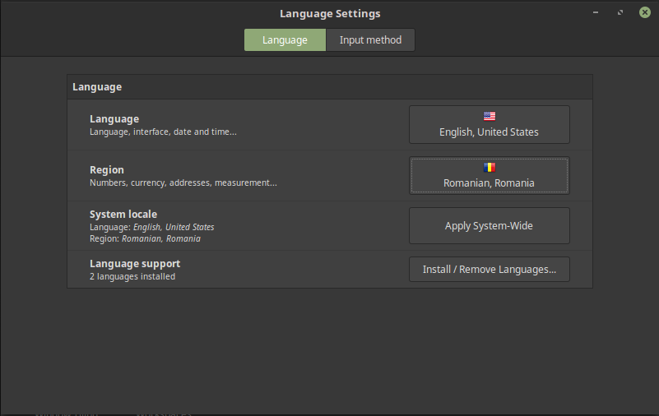
It is very easy to change the language in Cinnamon. As you can see I set mine in English, but I can change it at any time. To install a language click on the 4th button, type your password and a window will appear. At the bottom simply chose “Add”.

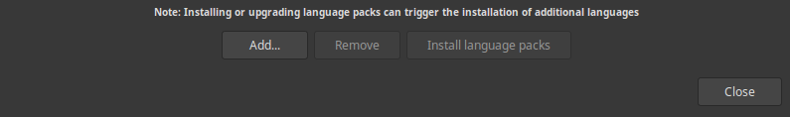
Then choose what language you want by selecting one and click install. You may see some intimidating red text warning you that some language packs are missing. Simply click on “Install language packs”. Now you can change the “Language”, “Region” and “System Locale”.

In the second tab there is “Input Method”.

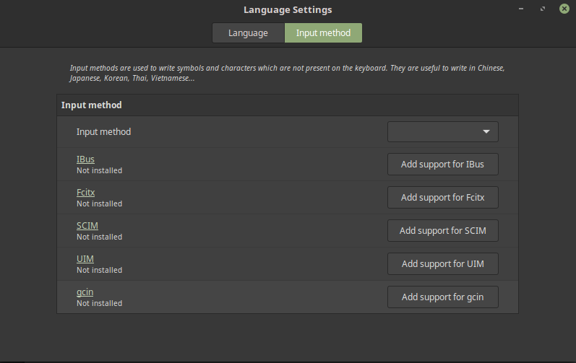
Unless you want support for Asian Languages for example than this really does not interest you, but one click is all you need. If you click on the “Add support for *”, you will be asked for your password. Simply wait and you are done. You may also want to install optional components as well which is again one click + password combo.

But wait what about some keyboard support? Well let's jump to that option next.

Keyboard

This one is in the Hardware section, so scroll down a bit.

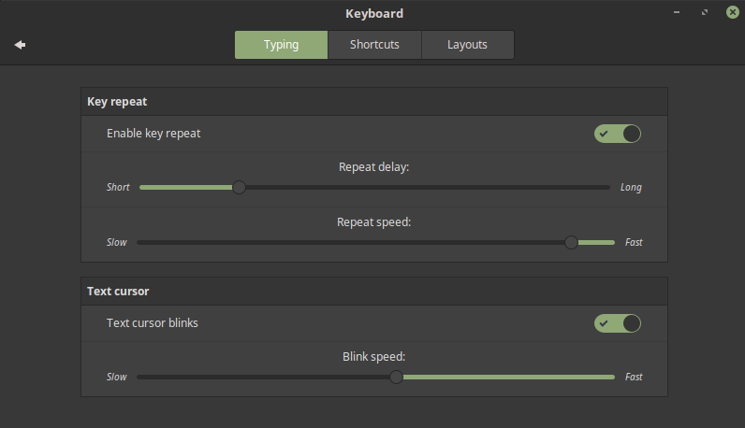
- In the “Typing” tab we have some options that most people are never going to bother with;
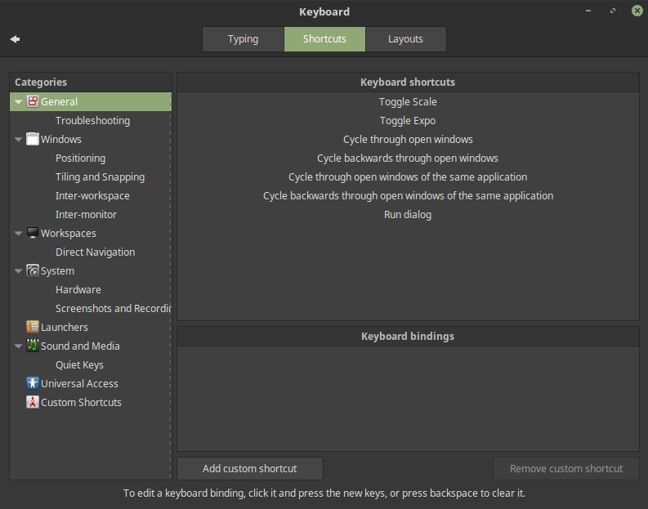
- In the “Shortcuts” tab we have some options that we should really look at:
  - Here you can change any shortcut in the system if you want to. To do that look around and find something you want to change. Than select what shortcut you want and at the bottom (in the “Keyboard bindings”) you can add 3 shortcuts. To edit a keyboard biding, click it and press the new keys, or pres backspace to clear it.
  - If you would like to add something go to the “Custom Shortcuts” on the sidebar and click “Add custom shortcut”. Give it a name and a command and bind it. Is that easy.
- In the “Layouts” tab we can add more keyboard layouts for our language needs.
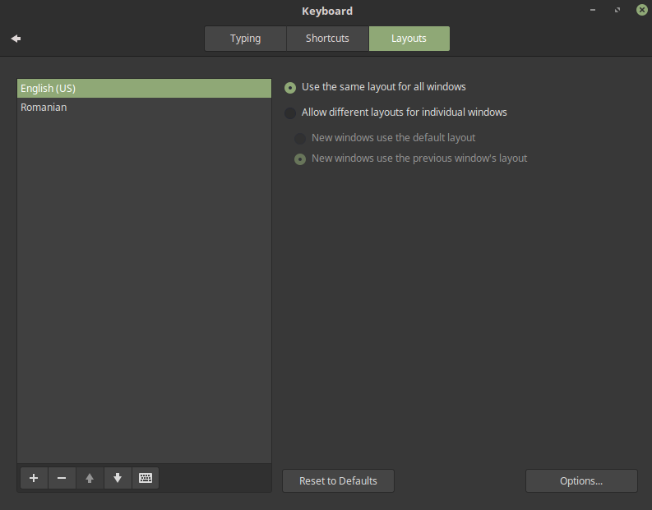
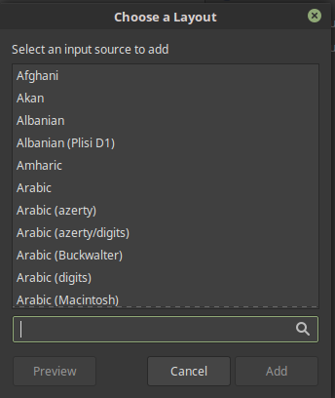
  - at the bottom you see a + a – up/down and keyboard icon. The plus will let you add more layouts;
  - select a language and click “Add”;
  - the minus will delete a layout;
  - up and down will move the layouts up or down;
  - the keyboard icon will show you a preview of the keyboard layout;
  - if you add layouts a little flag will appear in your panel where you can change between them. This is the “Keyboard” applet.
  - Ah, but the “Options” in the bottom right corner are a treat to people who hate things like Caps Lock;

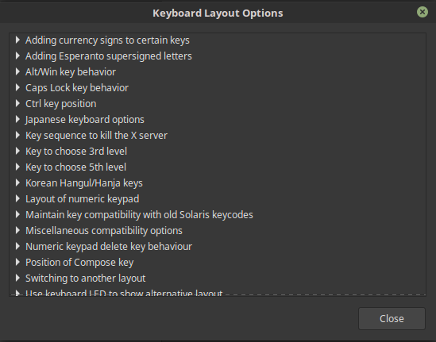
    - as you can see here we have some interesting options to play around with. So for example click on the “Caps Lock key behavior”. We can turn it off for instance or make it an additional ESC, etc.
      - as a side note Caps Lock becomes very useful if you turn into an enter key. To do that you can issue this 2 commands in a terminal:

xmodmap -e "remove Lock = Caps_Lock"
xmodmap -e "keycode 66 = KP_Enter NoSymbol KP_Enter"

      - you could even put this in a script if you want to. Create a text file and at the top put “#!/bin/bash” (no “”) than the commands above. Next we can have that run at startup.

Startup Applications

Ah well we can make shortcuts but how can we have something run at startup like a script or something, or turn off certain things to improve speed. Ah well there is setting for that.

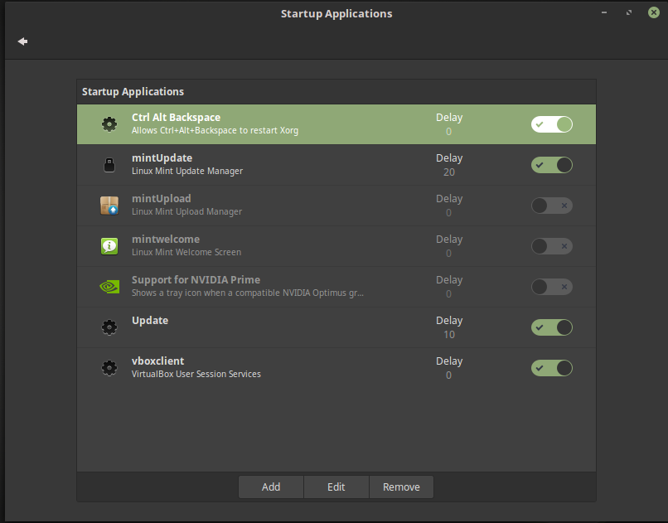
- By default there are some things here. You should leave things you don't know what they are alone. For instance “Ctrl alt Backspace” will force logout which is useful if things get out of hand (as a side note if you do CTRL+ALT+F1 you will open a real terminal, log in, and from here you can restart the PC or something; CTRL+ALT+F7 to get back to the desktop);
- at the bottom you can see “Update” which is something added. To add things click on the “Add” button:
  - you can choose a “Custom command” if you want to add a script or another command;
  - or choose “Custom application” and select something from the installed applications;
  - an edit option is also provided;

- as a side note there is also CRON which is more of a part of linux itself. To not jump into the terminal you can install gnome-schedule for a GUI.

Notifications

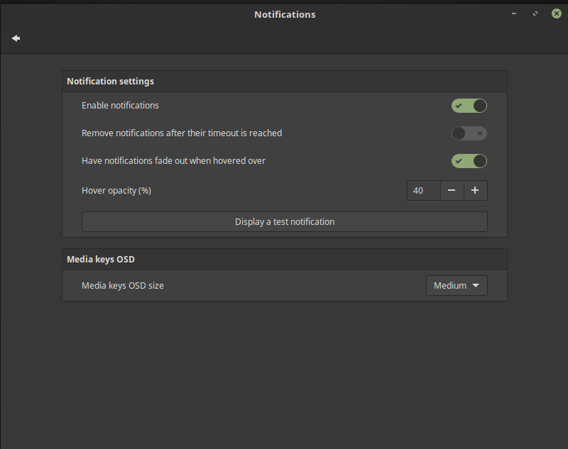
- the most important option here is to disable the notifications;
- click on “Display a test notification” to see how your changes affect the notifications.

Privacy
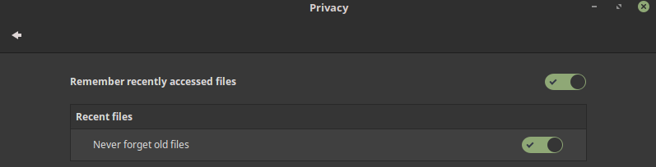
If you don't want recent files to appear in the menu or you are concerned about privacy than you can easily turn this option off.

Preferred Applications
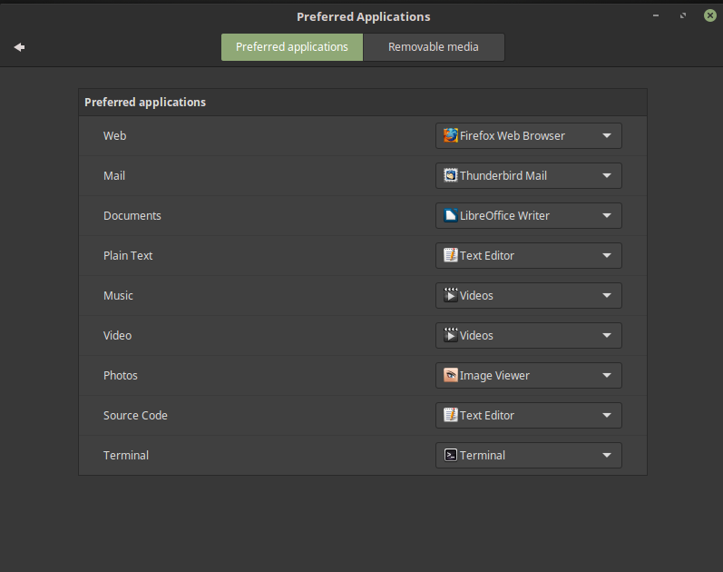

- here you can change the default applications to use when open a text file, videos, your preferred web browser and even the terminal emulator. Click on the little down arrow icon and select from a list of installed applications what you want.

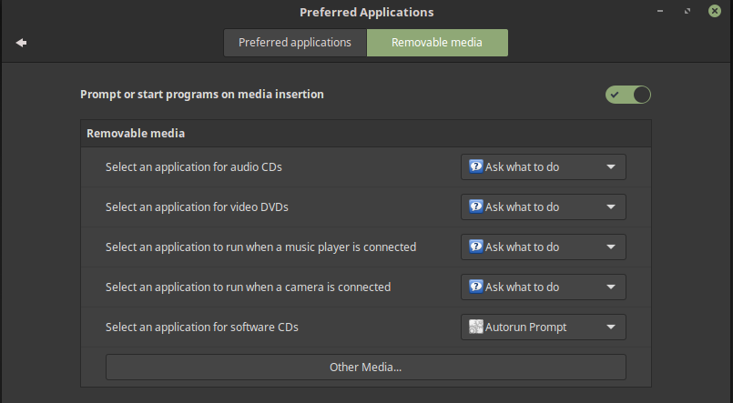
  - in the “Removable media” tab we can change settings regarding what to do when CDs, DVDs are inserted in the PC.

Screensaver

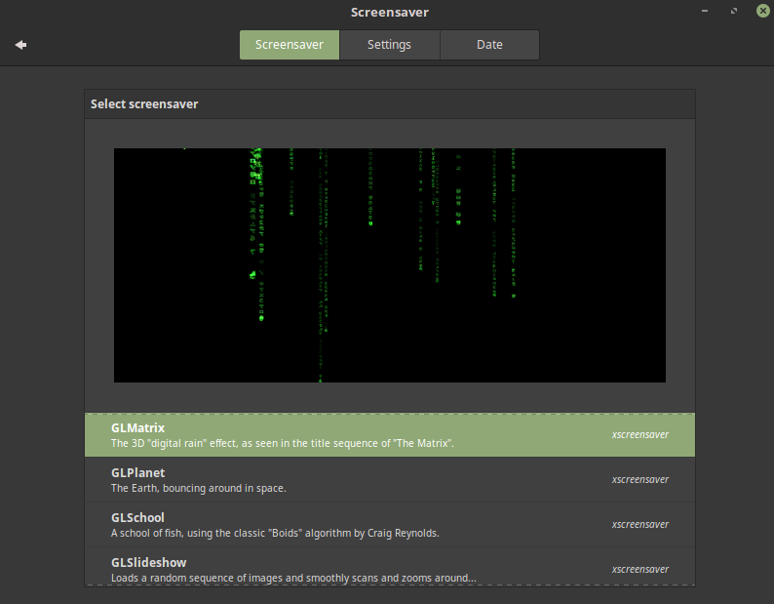
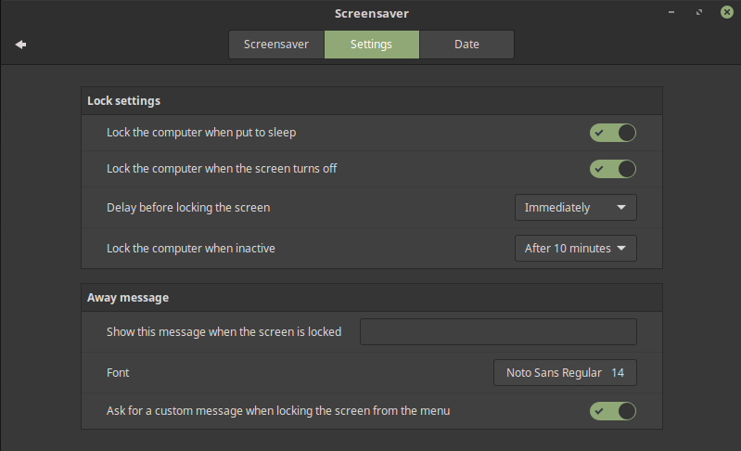
Cinnamon has of course screensavers to choose from. The one above is part of xscreenasver (you may need to install it if your are not using Linux Mint). There are so many screensavers to choose from.
You can also choose if you want to lock the screen when the screensaver starts. This is a security setting. You can also select how much time the computer stays idle until it is locked. In the date tab we can change how the date is displayed in the default screensaver (if you use another one like the GLMatrix the date will not appear).

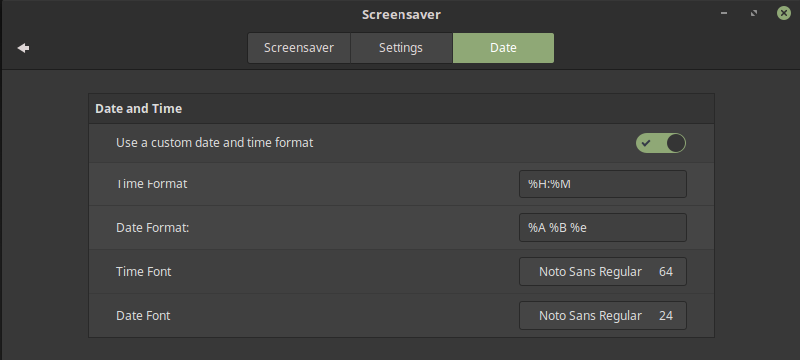
If you want to start the screensaver at any moment you can use this command in a terminal:

gnome-screensaver-command –activate

You can also add it to the menu for example for easy access.

Login Window
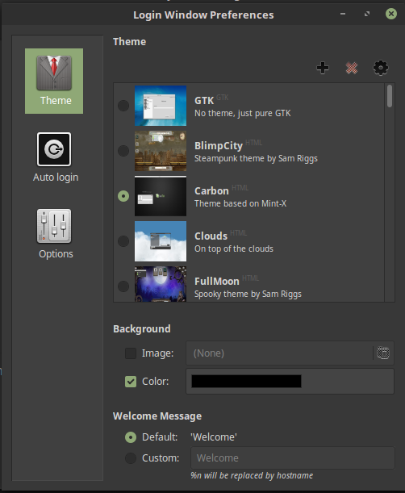
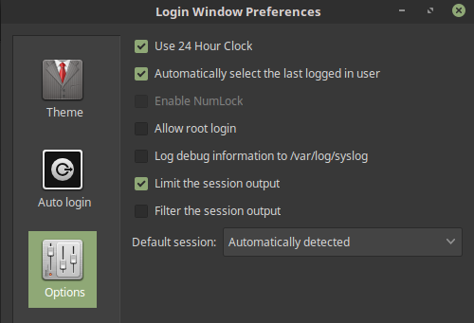

The login window is another little visual customization you can tweak to make your PC your own. Now, you don't spent much time on the login screen, but it too has to look nice.

In the theme tab you can choose between many different styles from simplistic to very complex. Keep in mind that more complex it is, more resources it needs, so for speed you may want to use a simpler theme.

Do you see that little + ? You can add another theme.

The wheel will allow you to see what the theme looks like without having to restart all the time.

In the “Auto login” tab you can have Linux Mint login in your account right away without any stress.

In the “Options” tab you can select what desktop environment is used by default and even allow root login (which you shouldn't do).

Windows

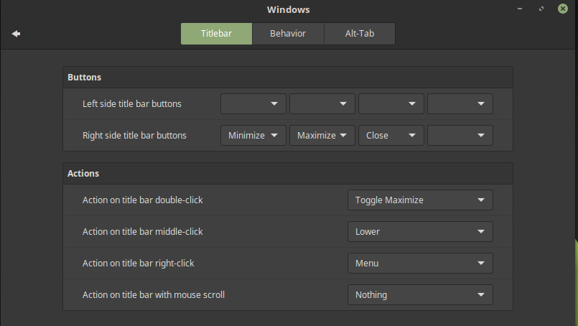
In the “Titlebar” section you can place to minimize, maximize and close button either to the right or to the left:
- simply click on the little arrow and choose what you want;
- for example the menu is the same as pressing ALT;
- you can also have actions for example on double click;
- very useful is to make middle-click “Toggle always on top” and have the mouse scroll to shade (which will roll up the window in the titlebar).

In the “Alt-tab” you can change how alt-tab appears (it's style). For example try Timeline 3D for a more Windows-like style.
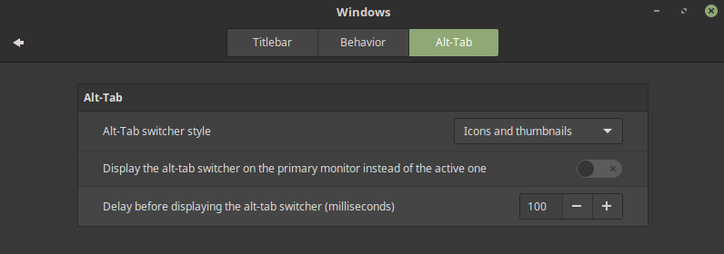

In the “Behavior” tab we can change how windows focus and when they appear on the screen. By default windows appear in the center but you can change to make the appear at the position of the cursor.

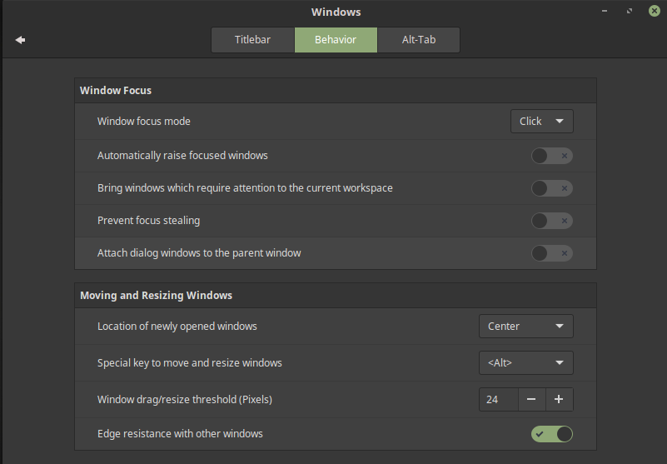
Window tilling

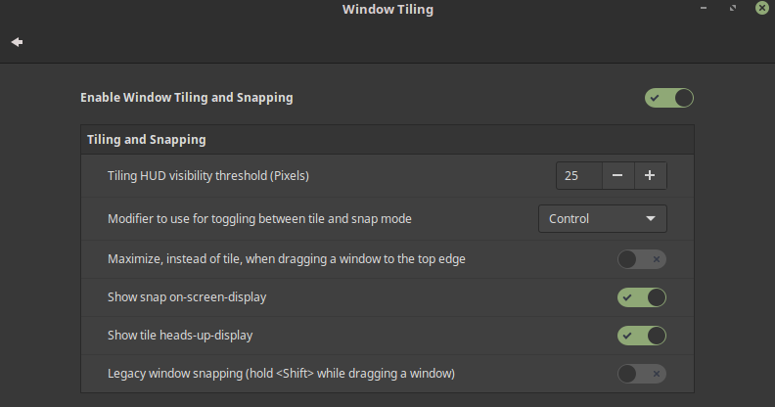
This is the snapping section. By default Cinnamon can allow you to snap like follows: to each corner, to each side and when press against the top it will fill the top half (instead of being maximized; double click the titlebar for this, unless you modified that).

The “modifier” key will allow you to easily move from one workspace to another.

Hardware settings

In this section there are many settings that will not be presented here such as Bluetooth, color management and printers.

Display
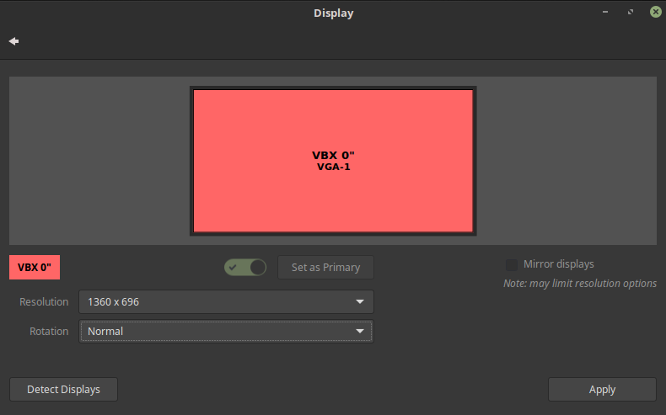
- easily select any resolution from here;
- options go from 800x600 up to 2560x1060;
- multiple monitor setups also supported.

Mouse and touchpad

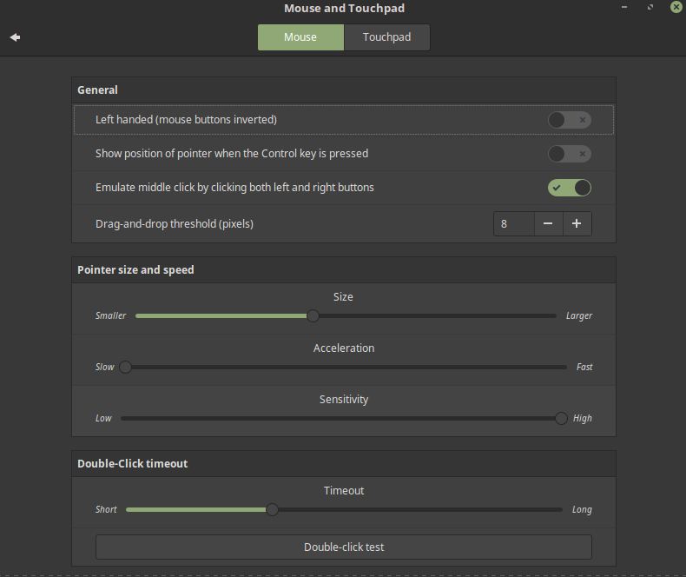
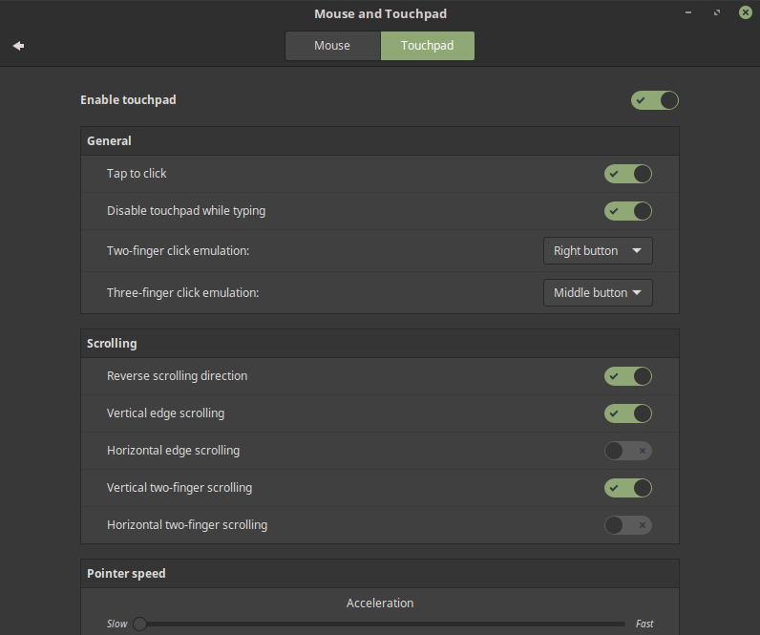
In the mouse section we can adjust the speed of different mouse actions such as it's movement or the double-click timeout. Cinnamon also provides options for a left-handed mouse (it will change the buttons around).

In the touchpad tab we have some very useful settings, that is the two/three-finger emulators, which are by far 2 settings that are indispensable for a laptop user.

Networking

In this section you can manage the internet connection. By default Cinnamon should pick up your wifi. On the other hand if you want to have a PPoE Connection, you can follow this steps:
- in the panel click on the “Network manager” applet;
- click “Network Connections”;
- click “Add”;
- choose “DSL” as the connection type and click create;
- introduce your name and password (which were provided to you);
- click “Save...”
- click on the applet again and set “Wired” to on.

Power Management

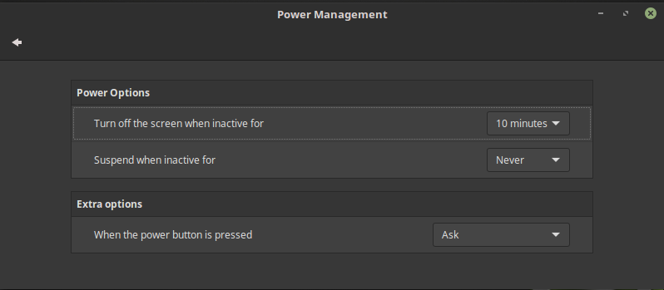
In this section you can change when the screen is turned off and even what pressing the power button does.

System Info

Here you can see some information about your system. For even more information open up a terminal and enter this command: inxi -F

